**Character and Set Design Couse Work 1 Report**

**Introduction**

In this report I will be detail my entire design and modelling process for the robotic athlete. This will include the design pipeline, working and adapting from inspiration, the modelling techniques used, and justification to sing a wide variety of techniques that Maya has to offer.

**Pre-Production and Planning**

To begin with I created a style sheet and mood board in order to get inspiration and ideas about what I could use for my robot model (seen in appendix). I used pictures of robots from films such as *Real Steel*, *iRobot,* and *Star Wars*, along with some examples of real-life robots from companies such as Boston Dynamics. Along with these, I also added pictures of human Olympians in order to get ideas for both the types of movements the Robotic Olympoid should be able to perform, as well as ideas for real-world objects that could be modelled alongside the main robot as either props/items or as part of the Olympoid itself.

Initially I thought of a one-armed Robot with wheels as its way of movement. The idea behind the single arm was that the arm could be revolved at speed to enable good throwing performance by using centrifugal forces to its advantage. Utilising wheels would differentiate the robot from looking like a total human copy, something I didn’t want, as well as giving it good performance in track events.  
These factors changed however into a more traditional, human styled design with two arms and two legs. This was mainly for the fact that I preferred the look of two arms from my development sketches, plus the robot would be able to (theoretically) be able to perform well in a wider variety of sports with two arms (archery for example would be much harder with just one arm).  
I chose to replace the wheels with Para-Olympian prosthetic blades, as again I felt that these would provide more versatility in the sports that the Olympoid could compete in. Additionally, I felt that the blades fitted the design of my Olympoid much better than one with wheels.

After having done some development drawings, and playing with different ideas for the Olympoid, I settled on the features I wanted and began my final sketches and blueprints for the Robot. Blueprints from multiple angles allowed me to import these into Maya and model accurately from them. I chose to sketch out each body parts separately so that I could more accurately draw the different viewpoints needed to model from.

From the beginning I wanted my robot to have some sort of curved shape to it, to give a more interesting look. This was also coupled with the fact that in events such as running or swimming, aerodynamics will play a big part into how well the competitor can perform. Therefore, having an aerodynamic bevel on the front of the Olympoid’s body will be able to cut through the air or water to reduce resistance, akin to that of a human nose.

The style of the arms came from various images found in the style sheet. The shoulder and upper arm was inspired from the T-800 Terminator, having a exoskeleton of sorts and exposed wiring and hydraulics. The lower arm was based off a Real Steel fighting robot, and Sonny from iRobot, as well as the claw from the Boston Dynamic’s robot pictured in the appendix.

Inspiration for the leg can be seen from the artificial muscles that Sonny has in iRobot, as I liked the idea of mimicking a human’s mechanics in a robot. The lower leg uses a Para-Olympian’s prosthetic blade as mentioned above due to its versatility in many events, whilst also having a unique look to it compared to a traditional lower leg shape.

Finally, the head was inspired by BB-8 from Star Wars. The ability to look in 360 degrees, coupled with the non-human styled head appealed to me. I also felt that making the head irregular compared to a human head would add individuality to the design.

The decision to not draw top viewpoints for the arm and legs was made since the geometry for these would be very simple from this angle because of the spherical geometry of the shoulder pads and hip connector. Therefore, inferring how these parts should look would be easily achievable whilst modelling in Maya.

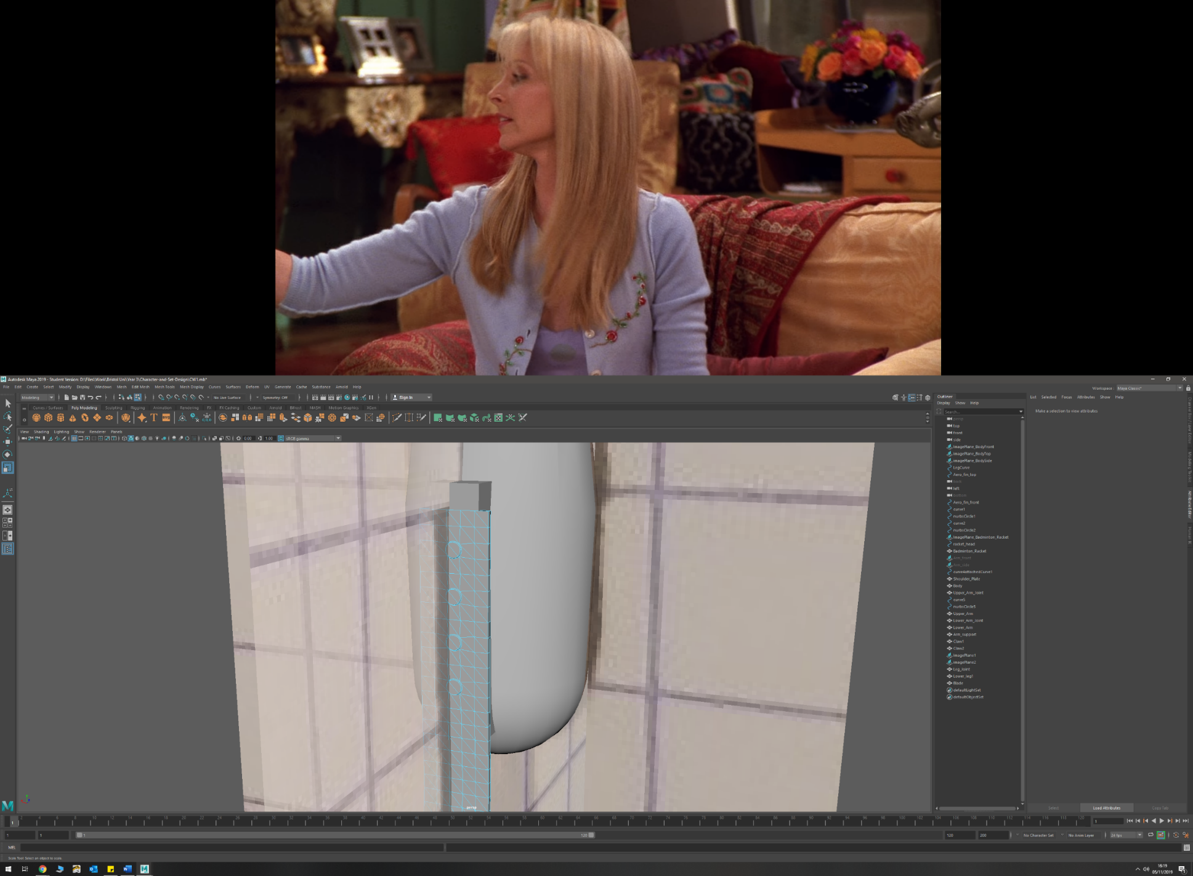**Techniques and Surfaces**

* Circularize
  + Camera on head
  + Screws on blade mount
  + Shoulder joint
* Primitive up modelling
  + Body
  + Leg (upper and lower)
  + Forearm
  + Badminton racket handle

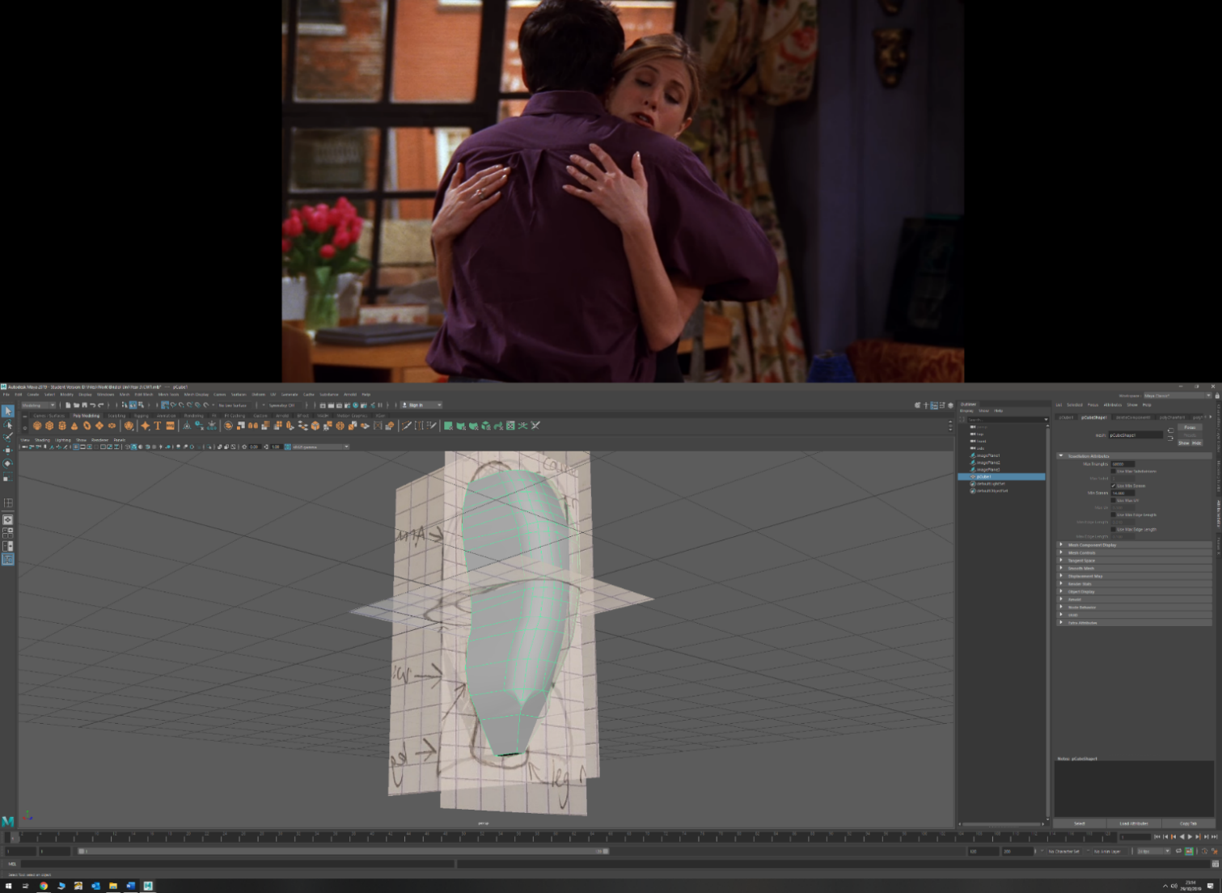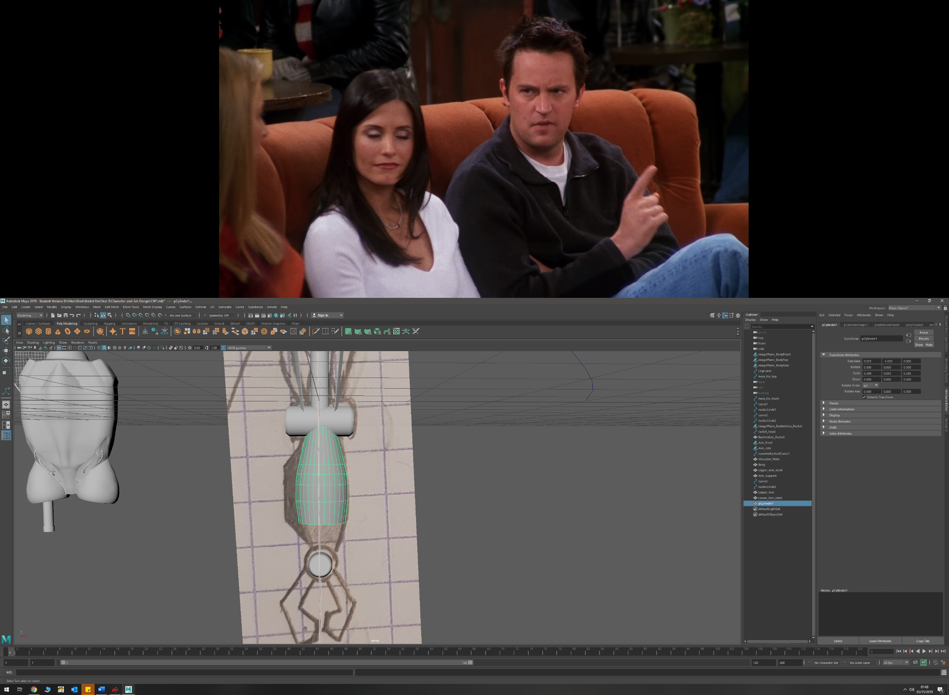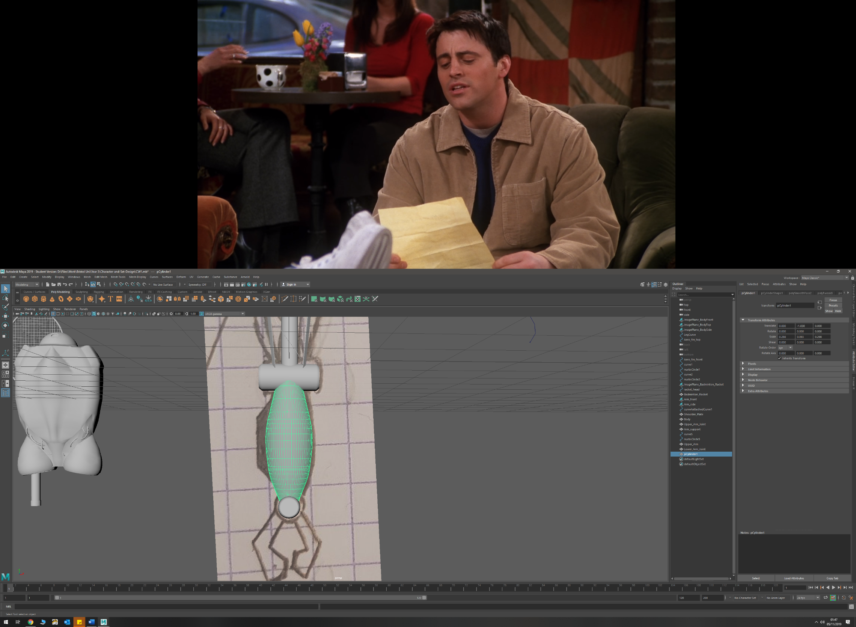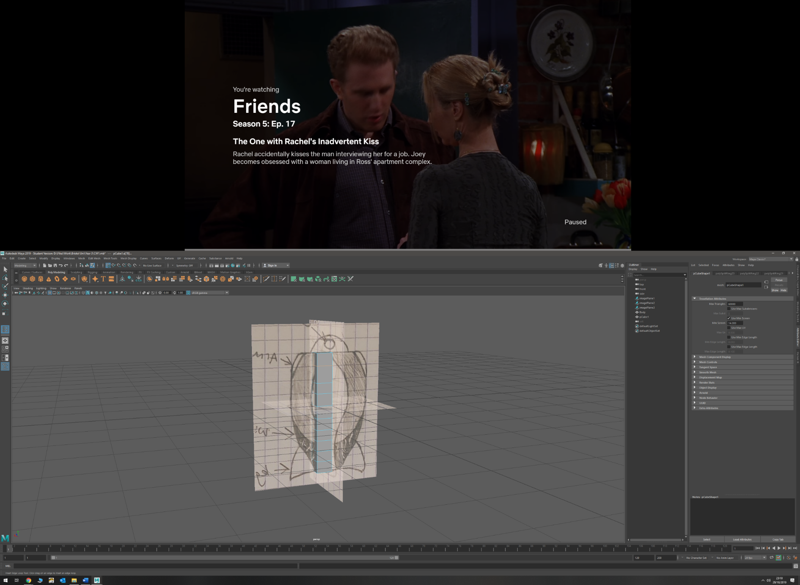

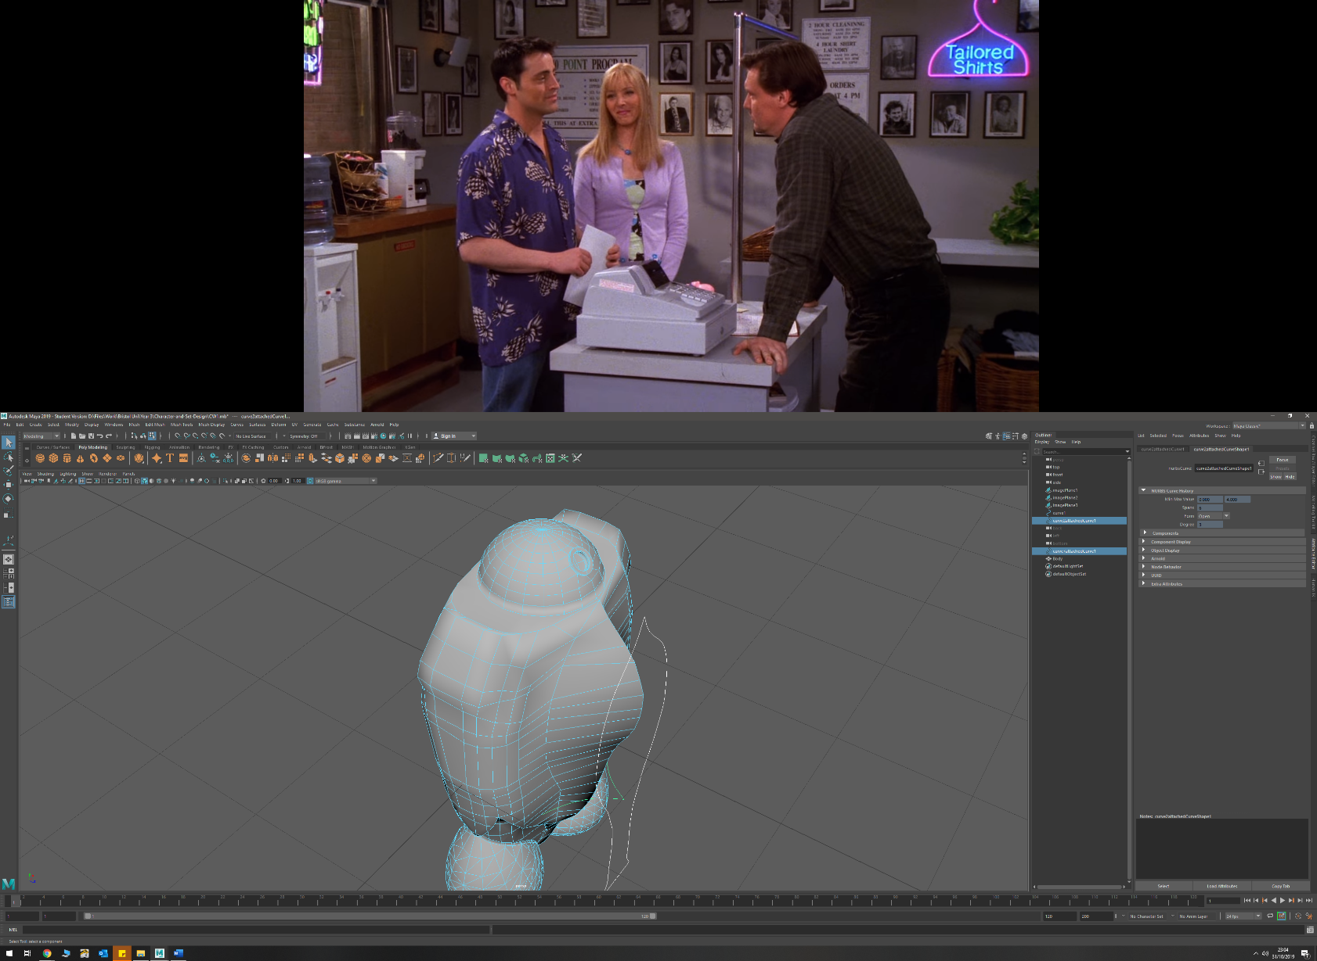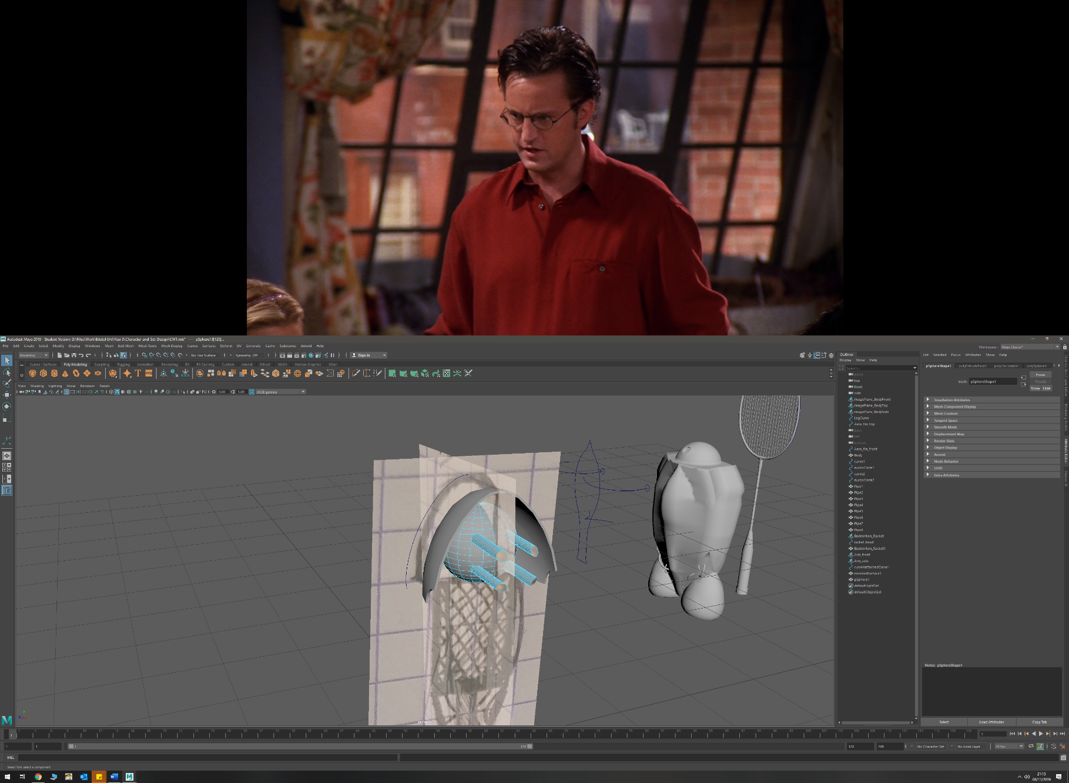

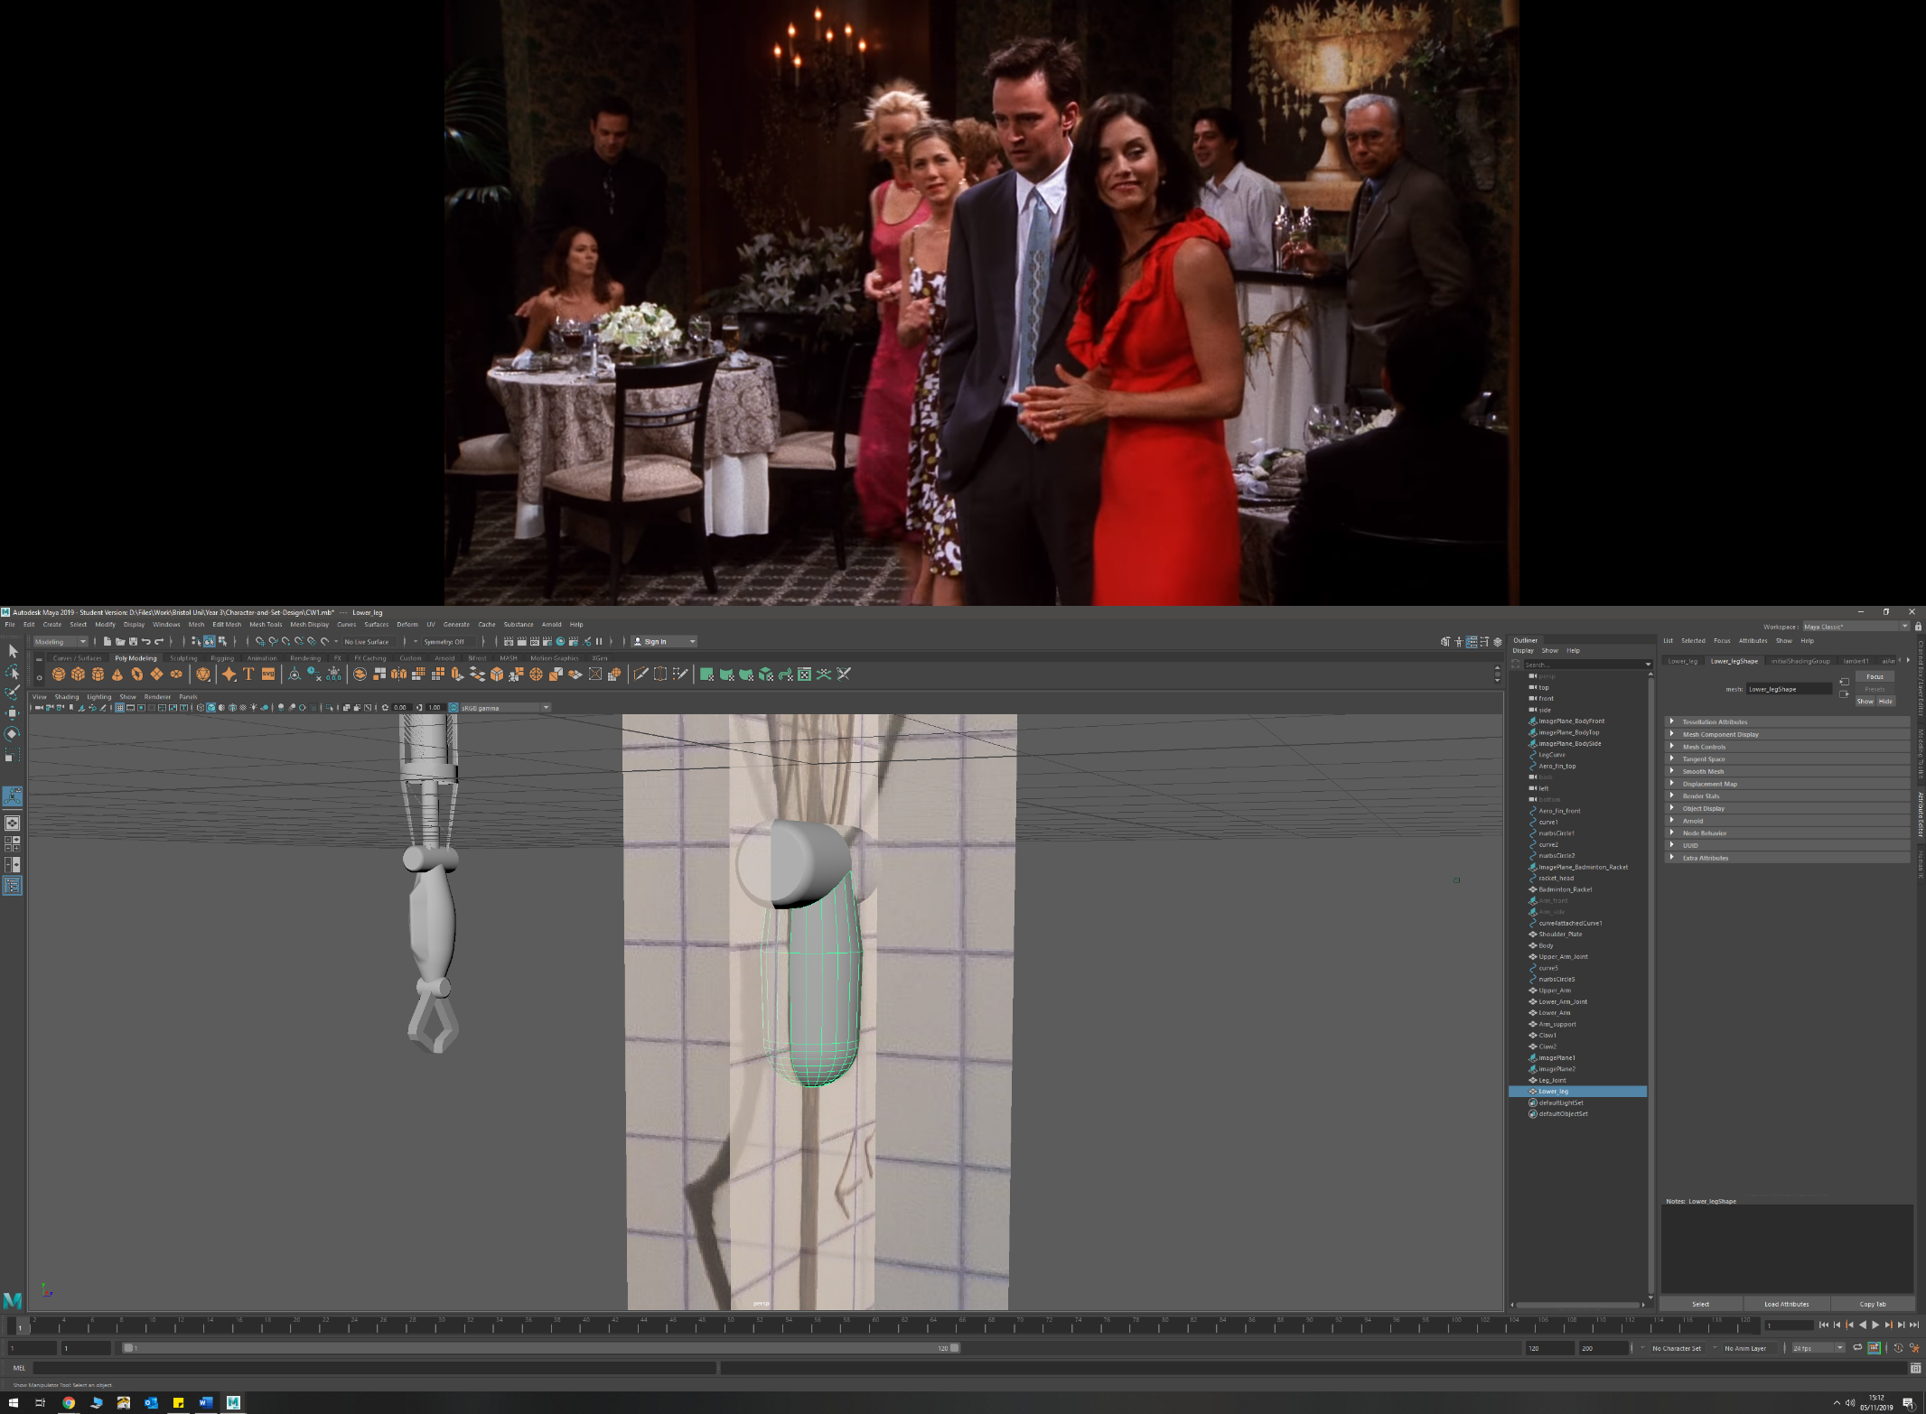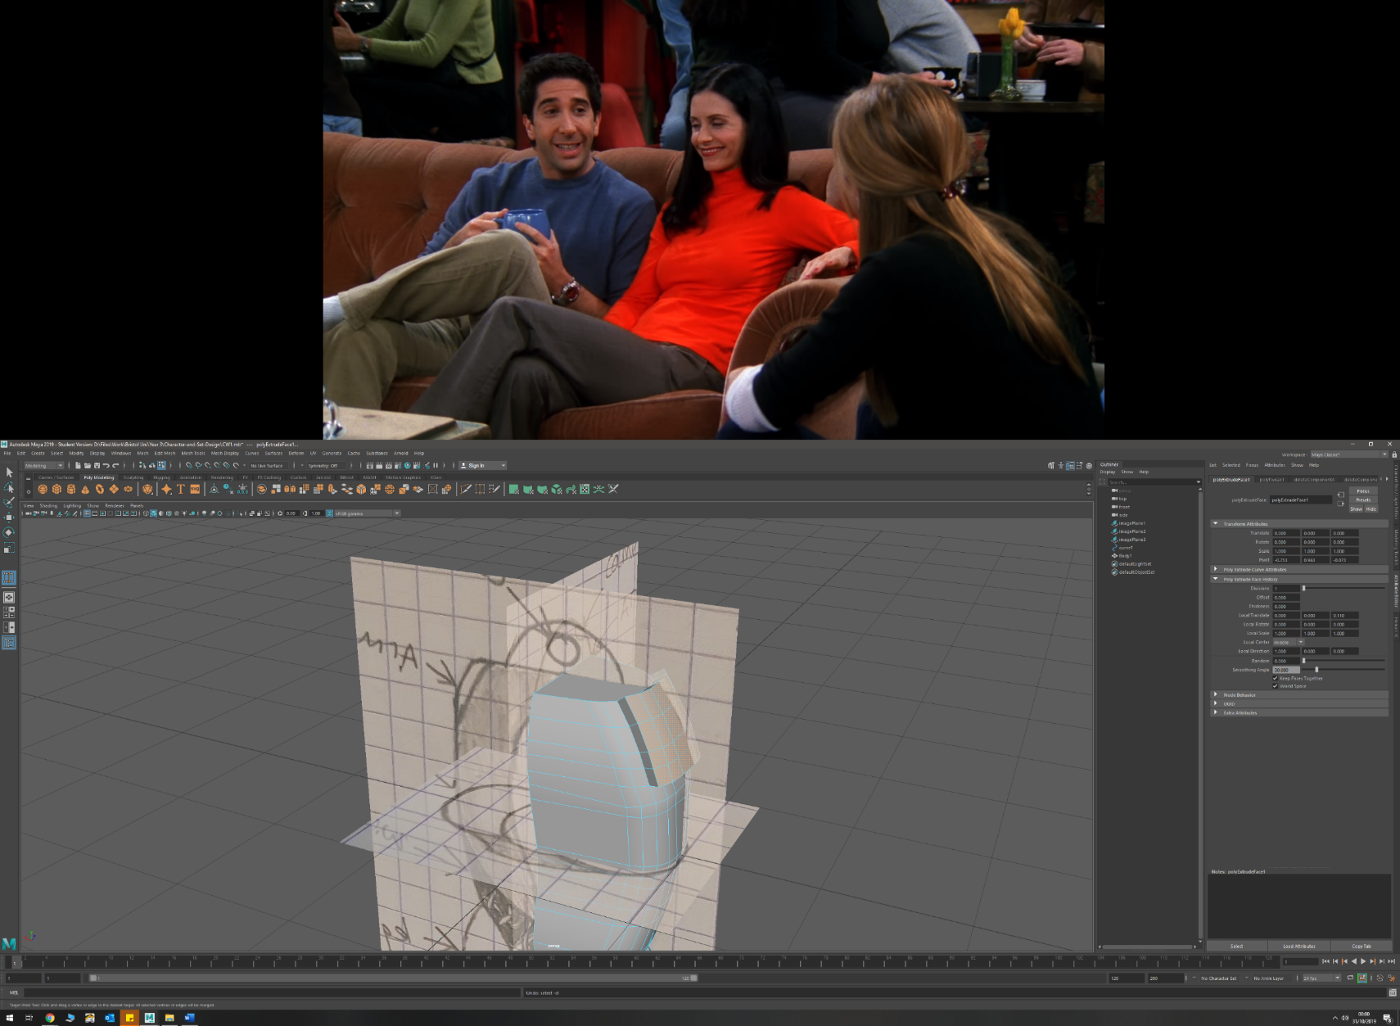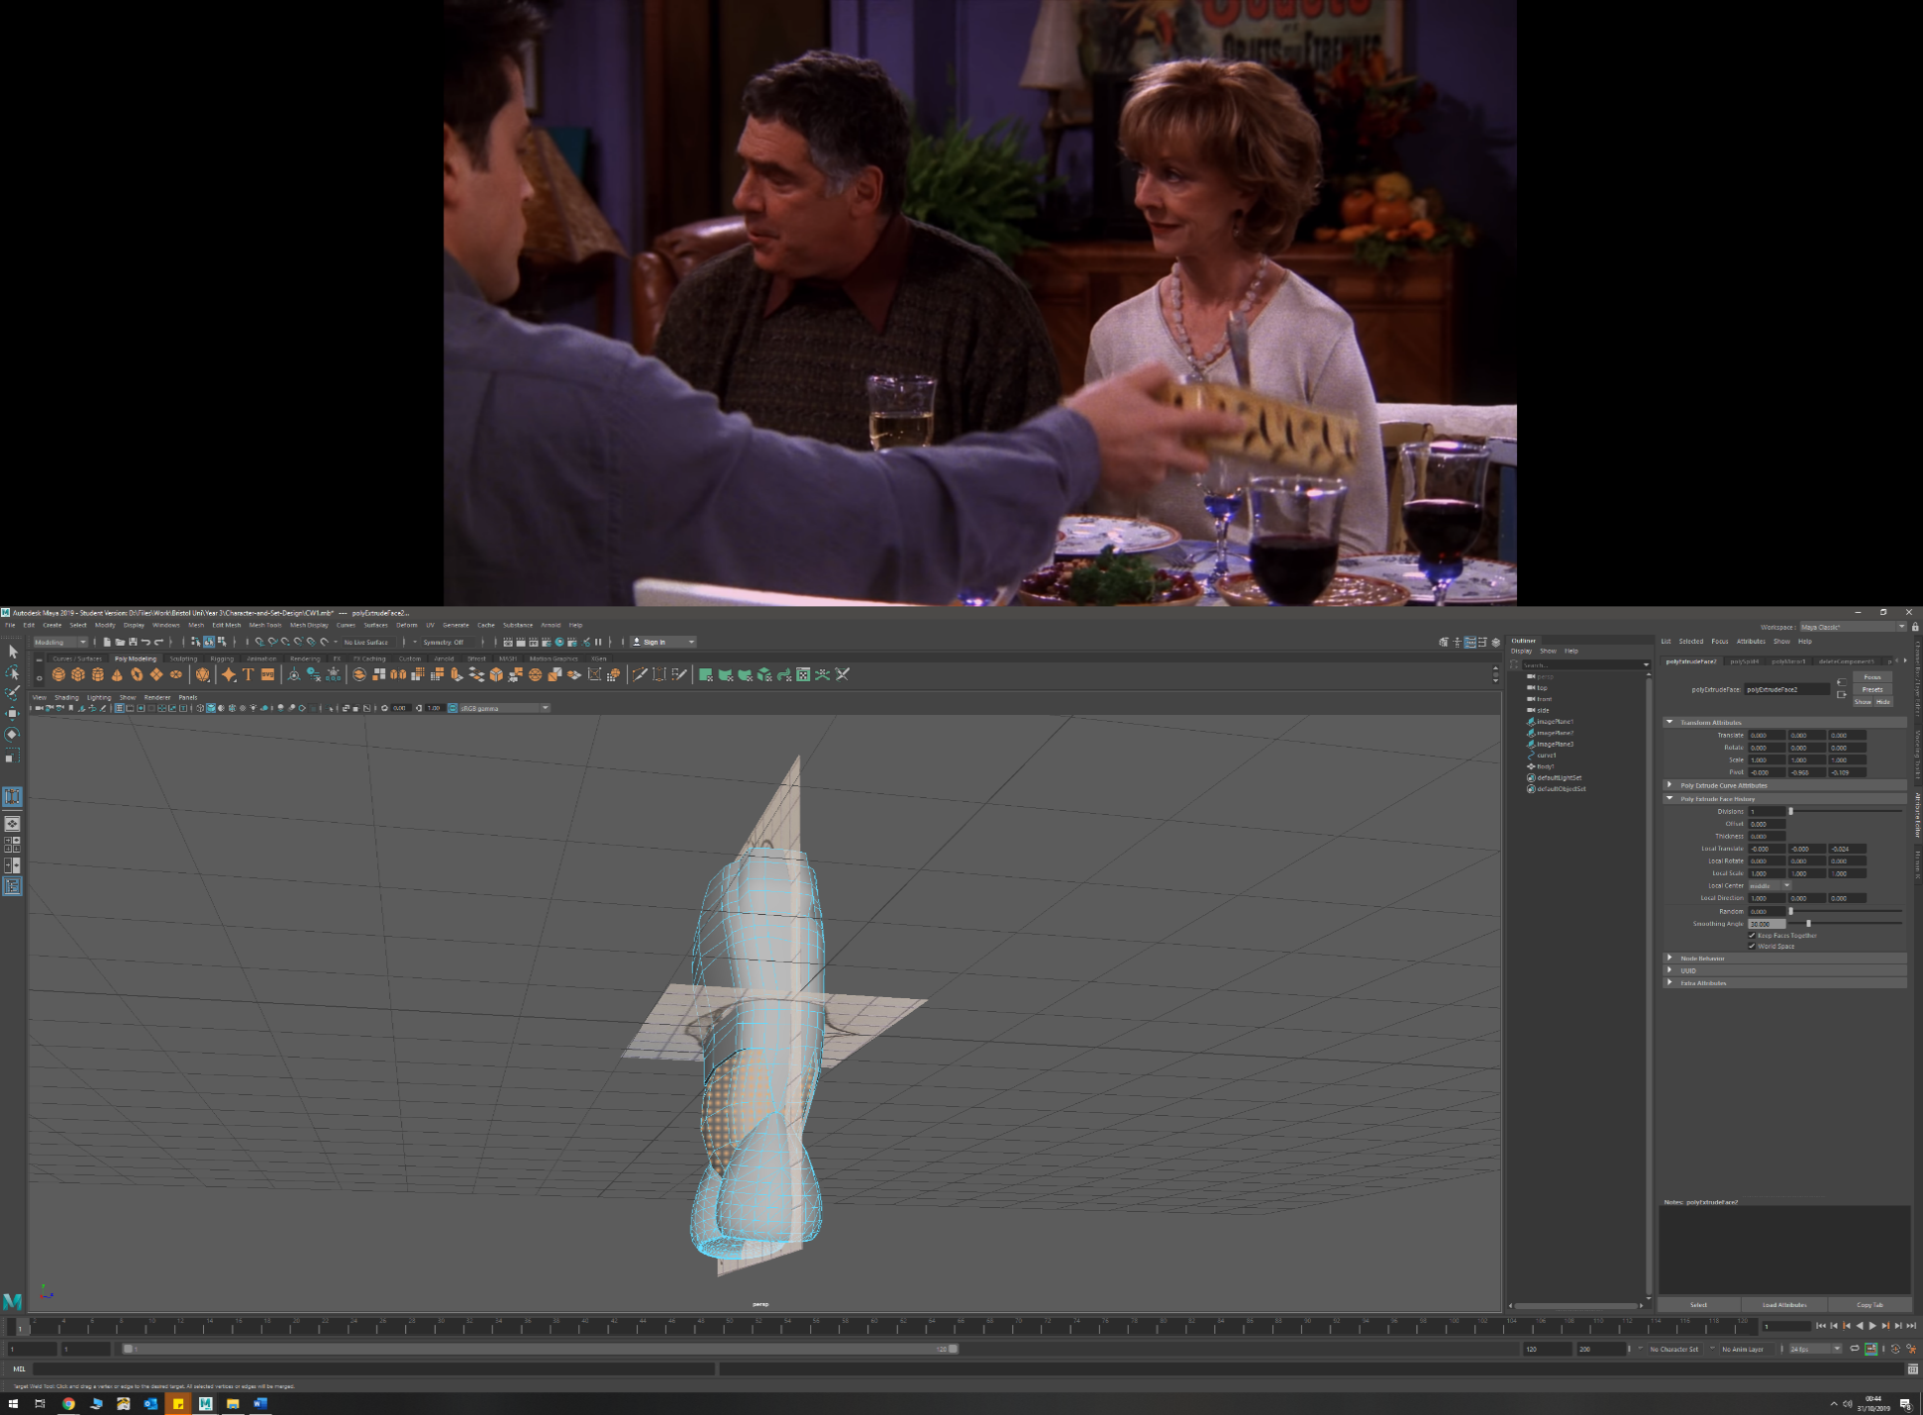

* Extruding faces (outward and inwards)
  + Shoulder mount (outwards) from torso
  + Lower torso detail (inwards) to create depth
  + Forearm (outwards)
  + Leg (upper and lower) (outwards)
  + Arm exoskeleton (outwards) to create thickness and the connecting arms to ring
  + Running blade (outwards) to create thickness
  + Head mount (inwards) to create the mount from original head
  + Badminton racket (faces outwards) to create handle and stem

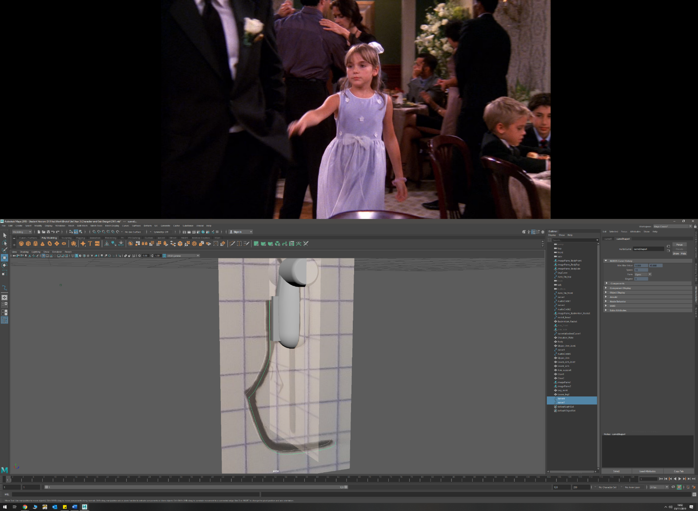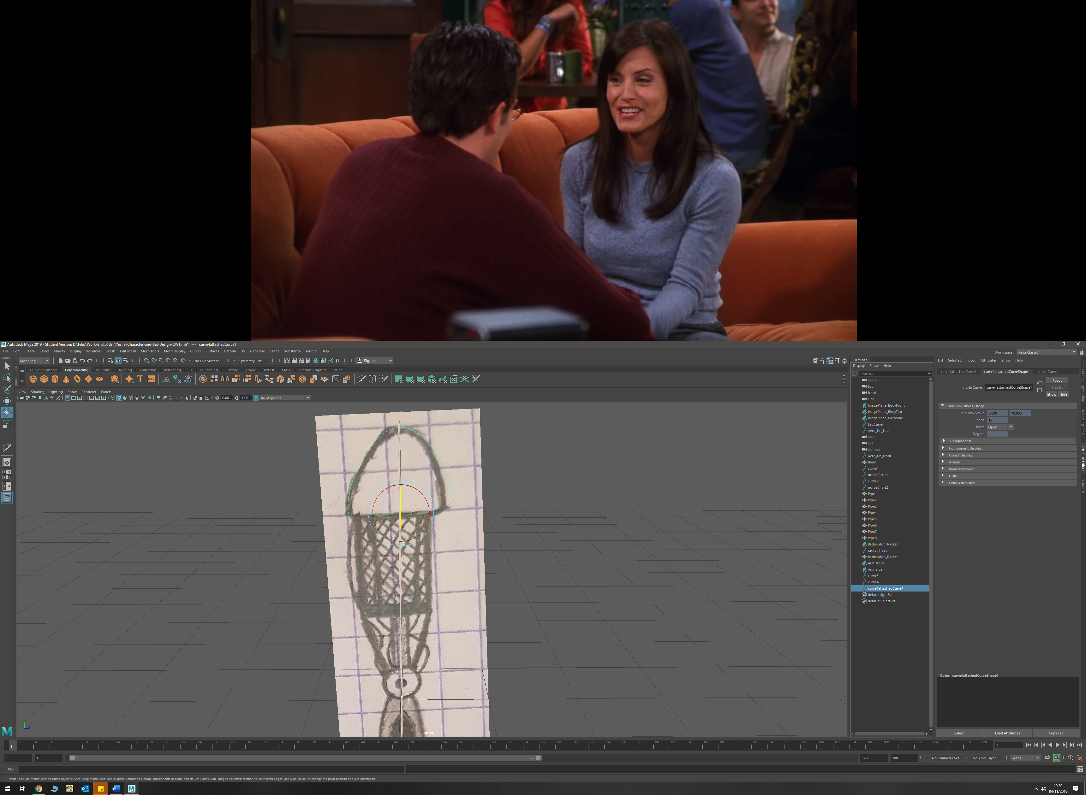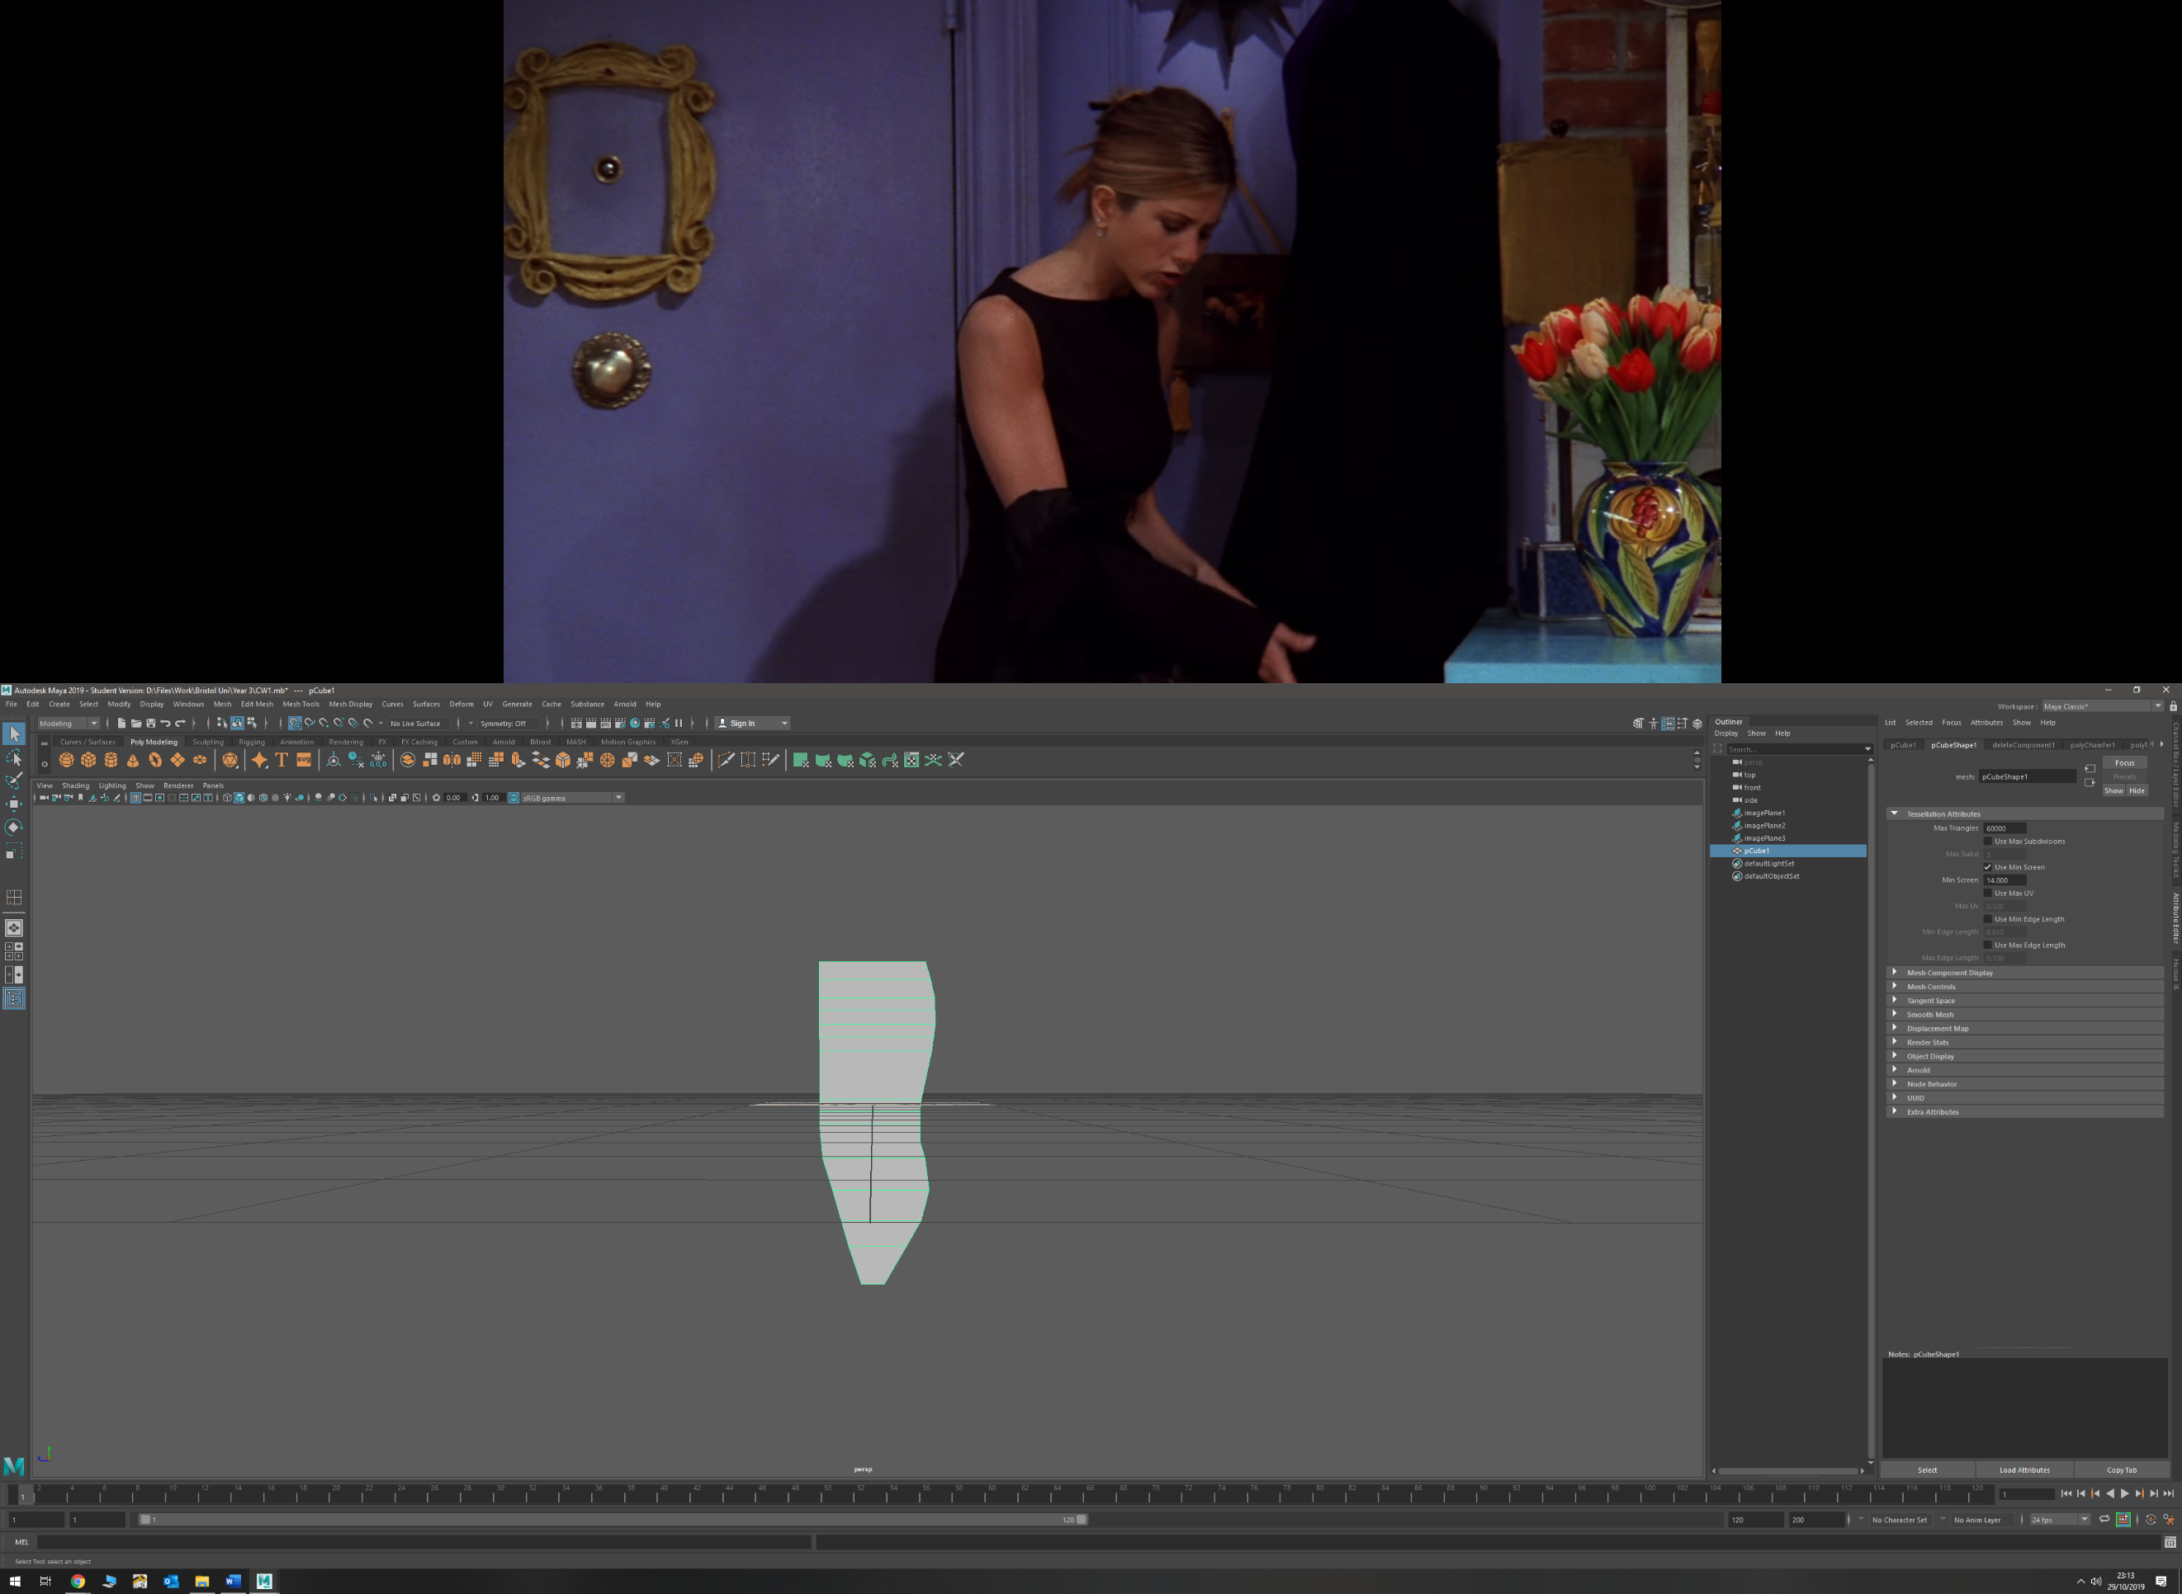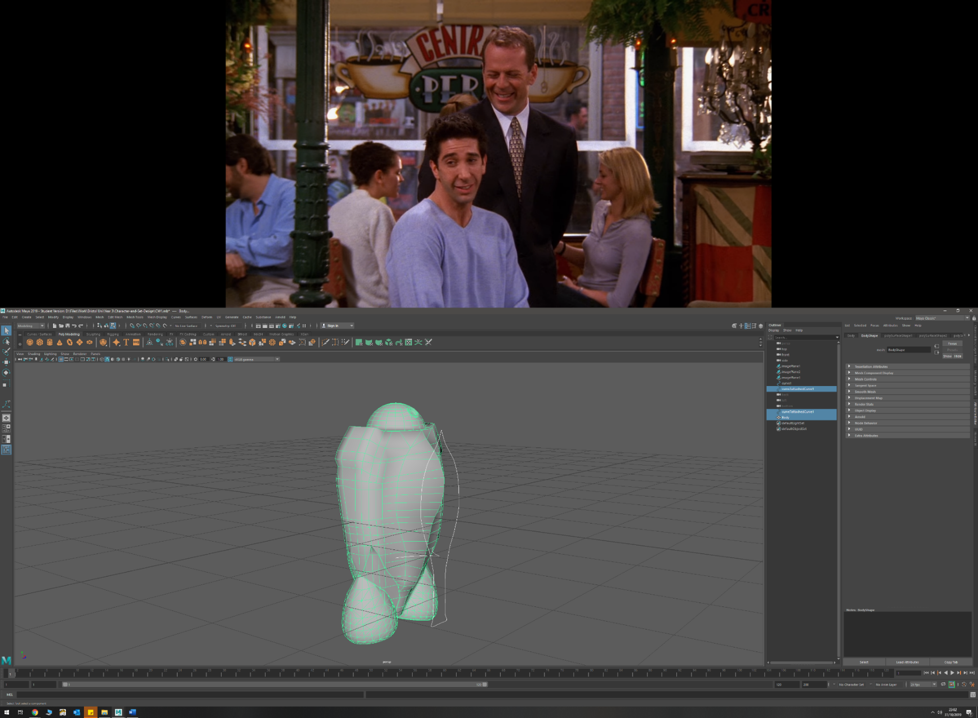v

* EP curves
  + Areo-fin
  + Running Blades
  + Shoulder pad
* Scaling faces and edges (outwards and inwards)
  + Arm (edges and faces outwards) to create forearm fin and taper forearm inwards
  + Leg (upper and lower) (edges inwards, faces outwards) to taper inwards at ends and add detail
  + Badminton racket handle (faces outwards) to widen stem for handle
  + Head mount (inwards)
* Sub-dividing
  + Torso
  + Torso Areo-fin

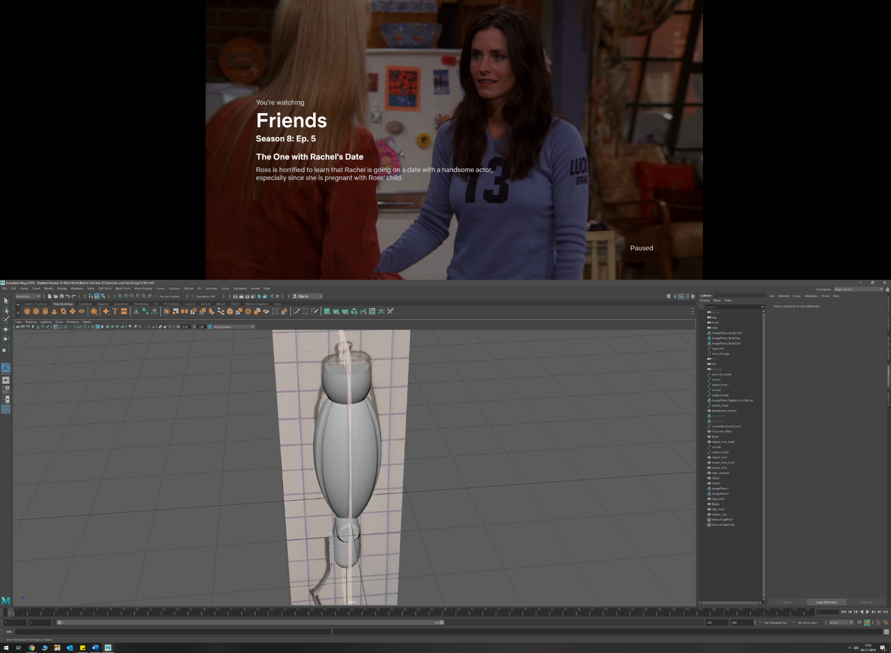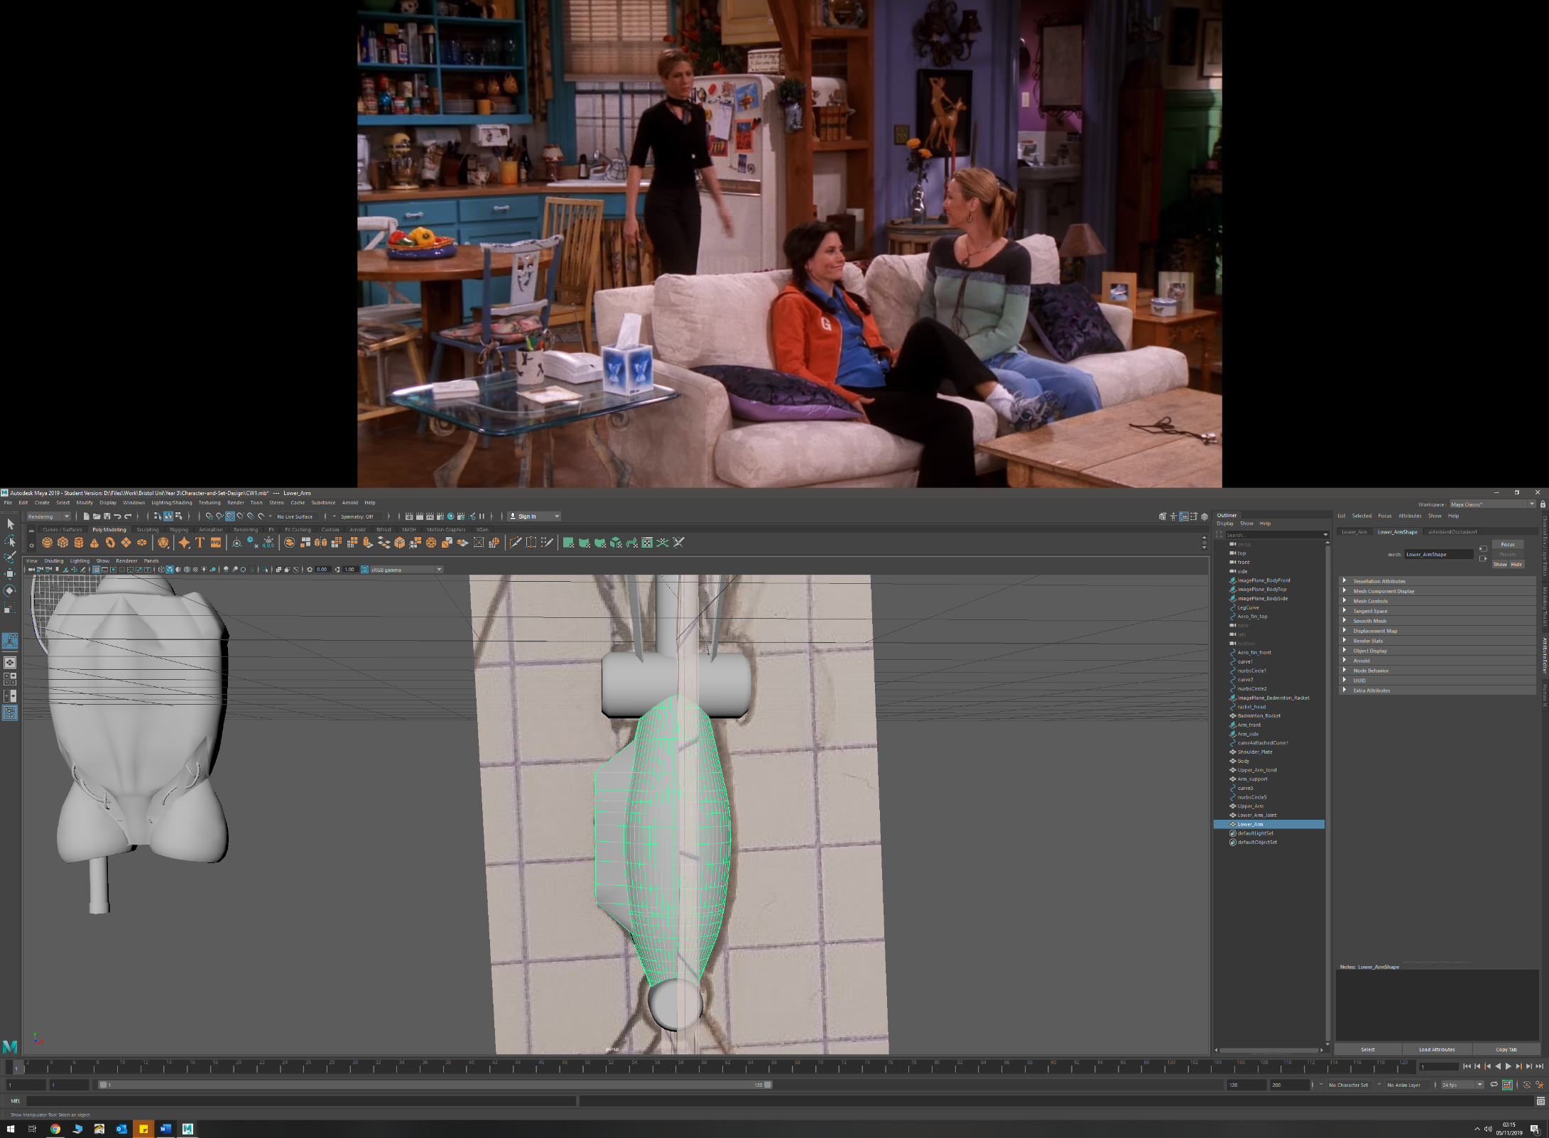

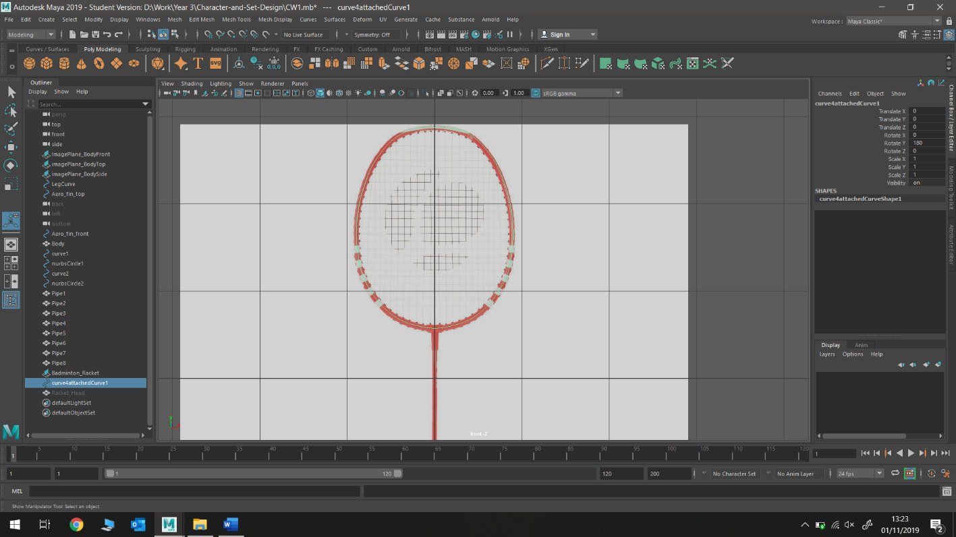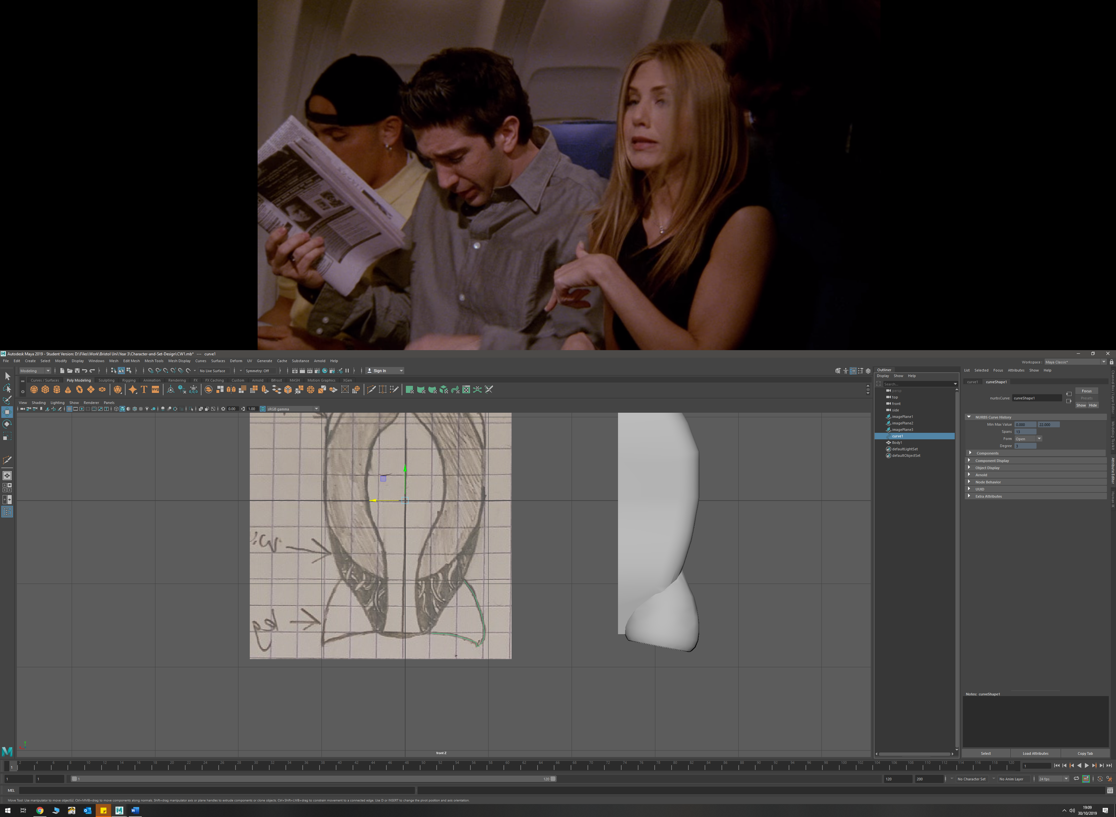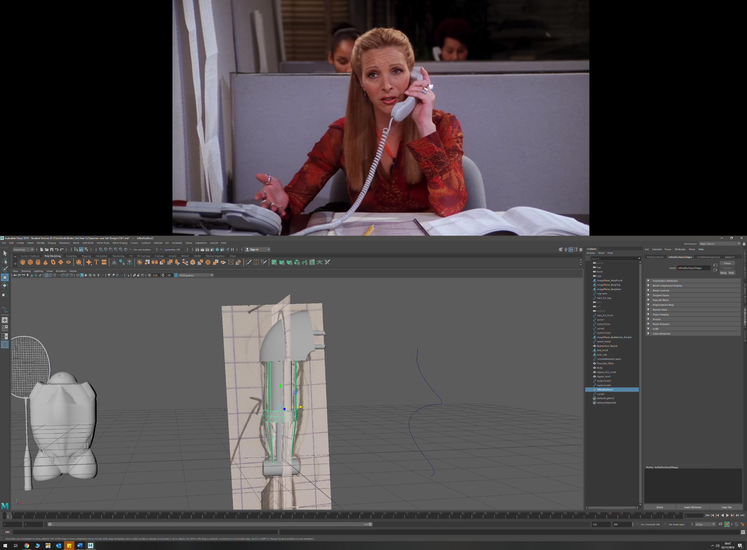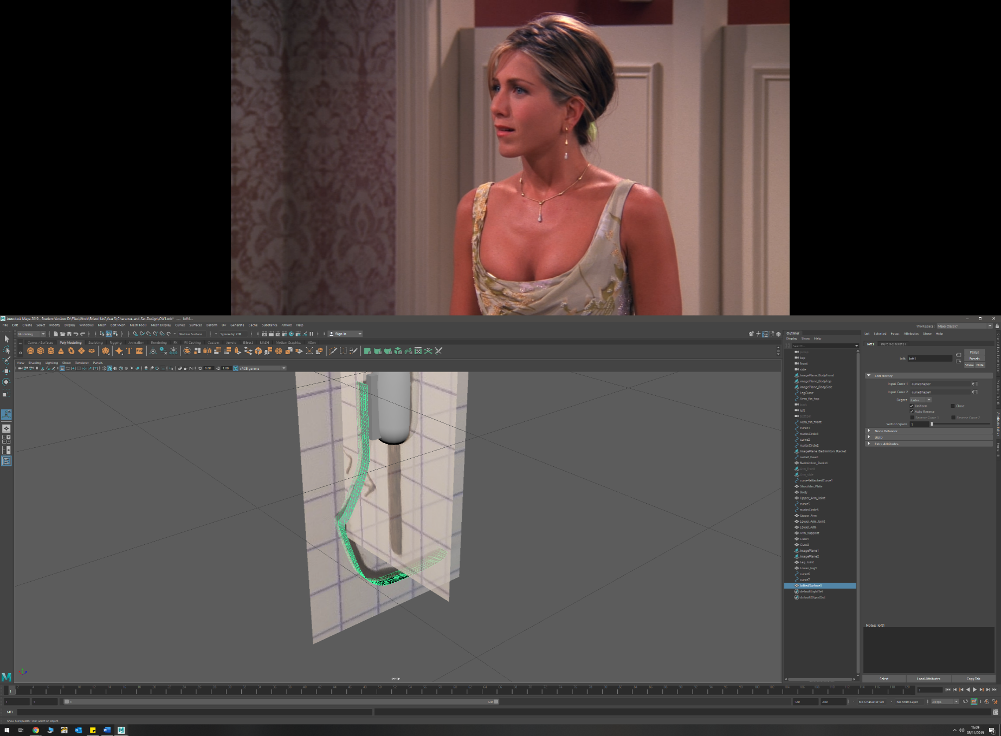

* CV curve
  + Badminton racket head
  + Leg mount
* Tracing from imported images with EP curve (real life and sketches)
  + Badminton racket (real life object)
  + Running blade (Personal sketches)
  + Shoulder pad (personal sketches)
* Lofting between two curves
  + Arm Exoskeleton
  + Running Blade

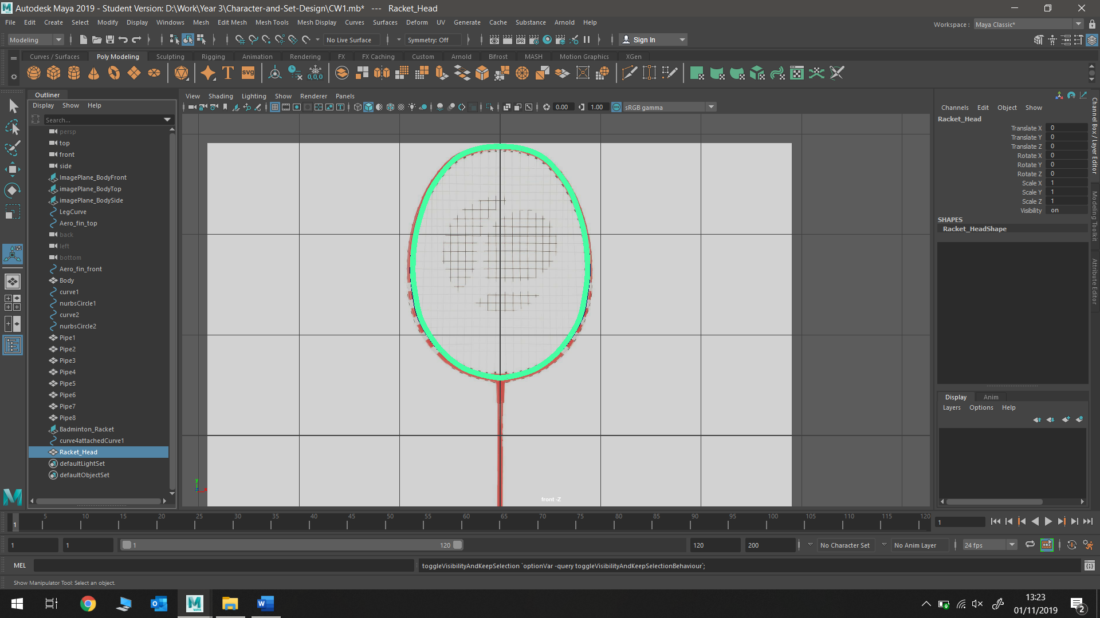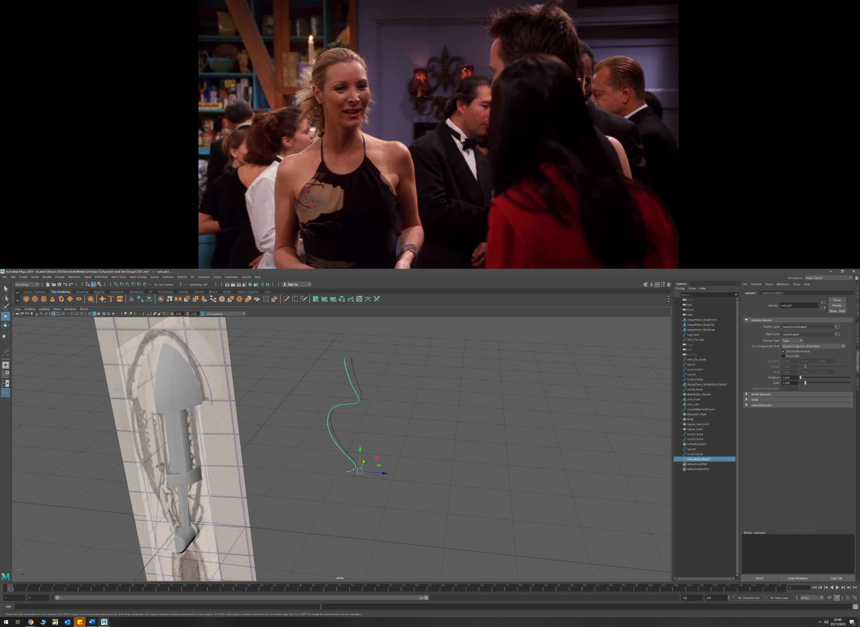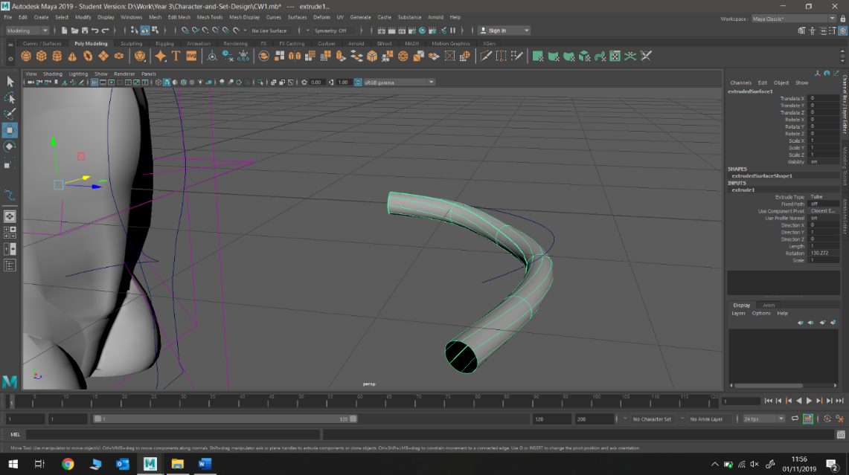

* Target Welding
  + Shoulder mounting plate
  + Torso
  + Forearm
* Extruding a NURBS along a curve (with and without twist)
  + Torso pipe details (with twist)
  + Arm wire detail (no twist)
  + Badminton racket head (no twist)

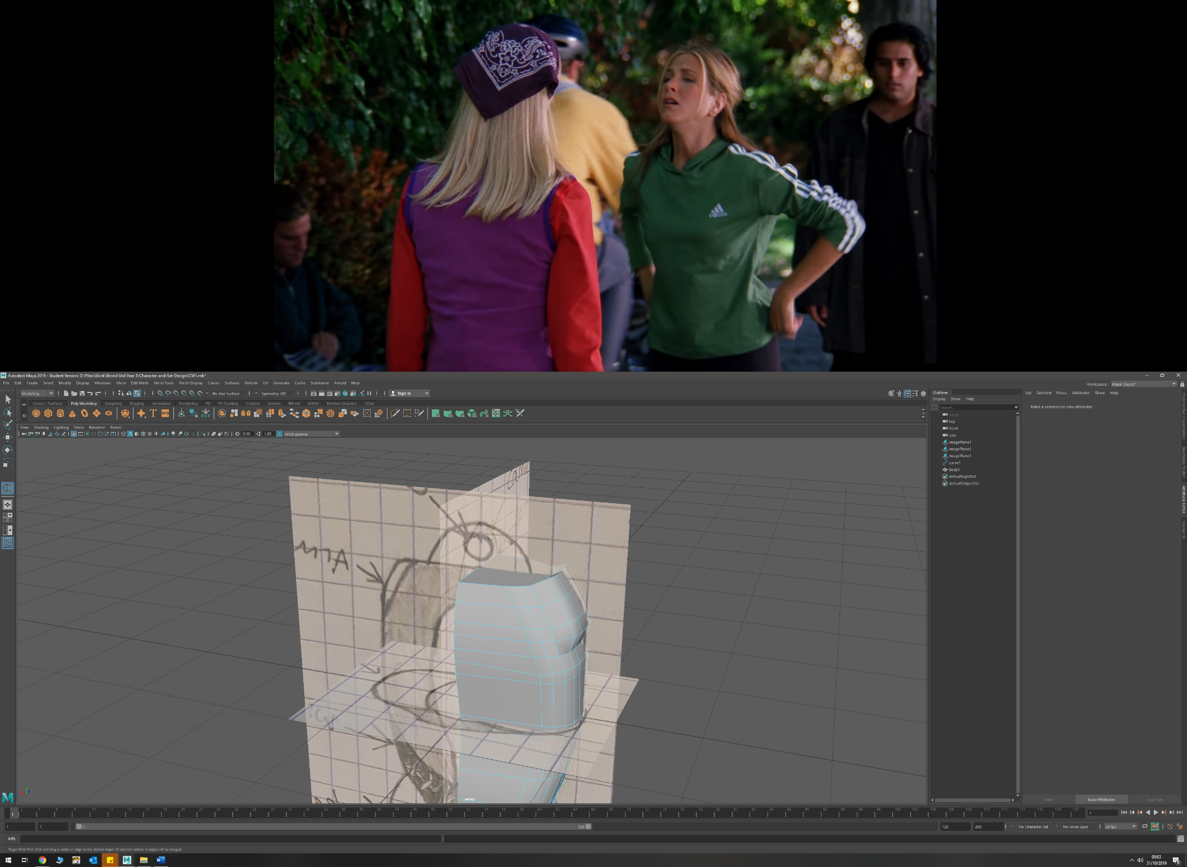

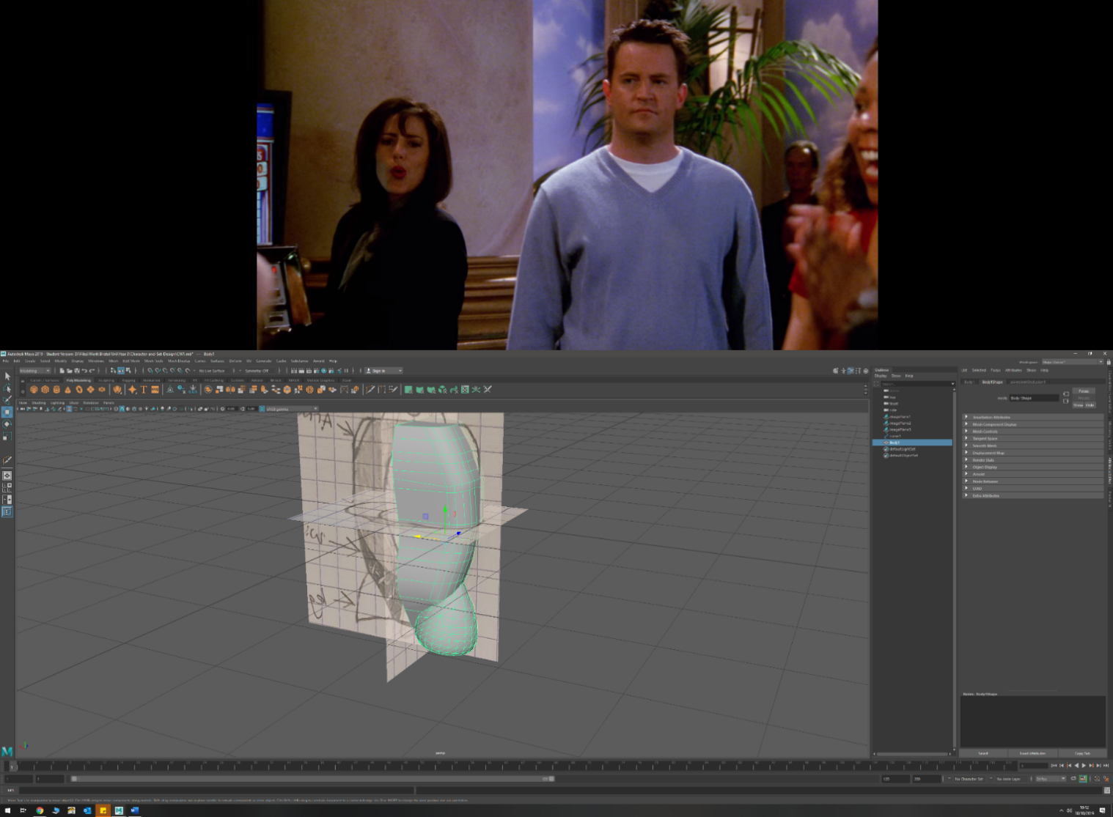

* Bevelling on edges and vertices
  + Torso front and read edges near shoulders
  + Claw end
* Boolean union, difference
  + Racket mesh (both)
  + Arm Exoskeleton mesh (both)
  + Leg mounts and torso (union)
  + Arm – to shape upper and lower arm around joint (difference)
  + Leg – to shape upper and lower leg around joint (difference)

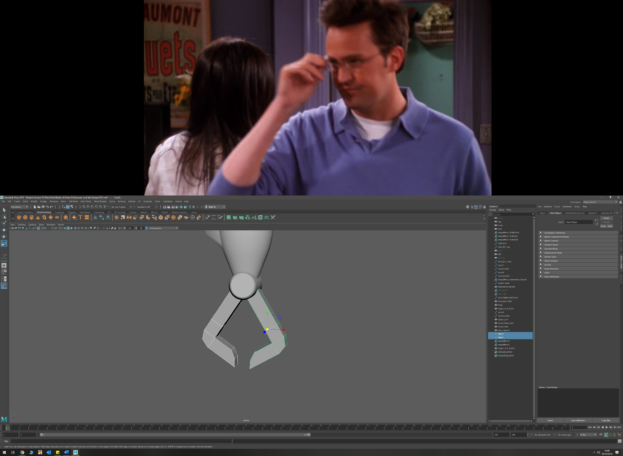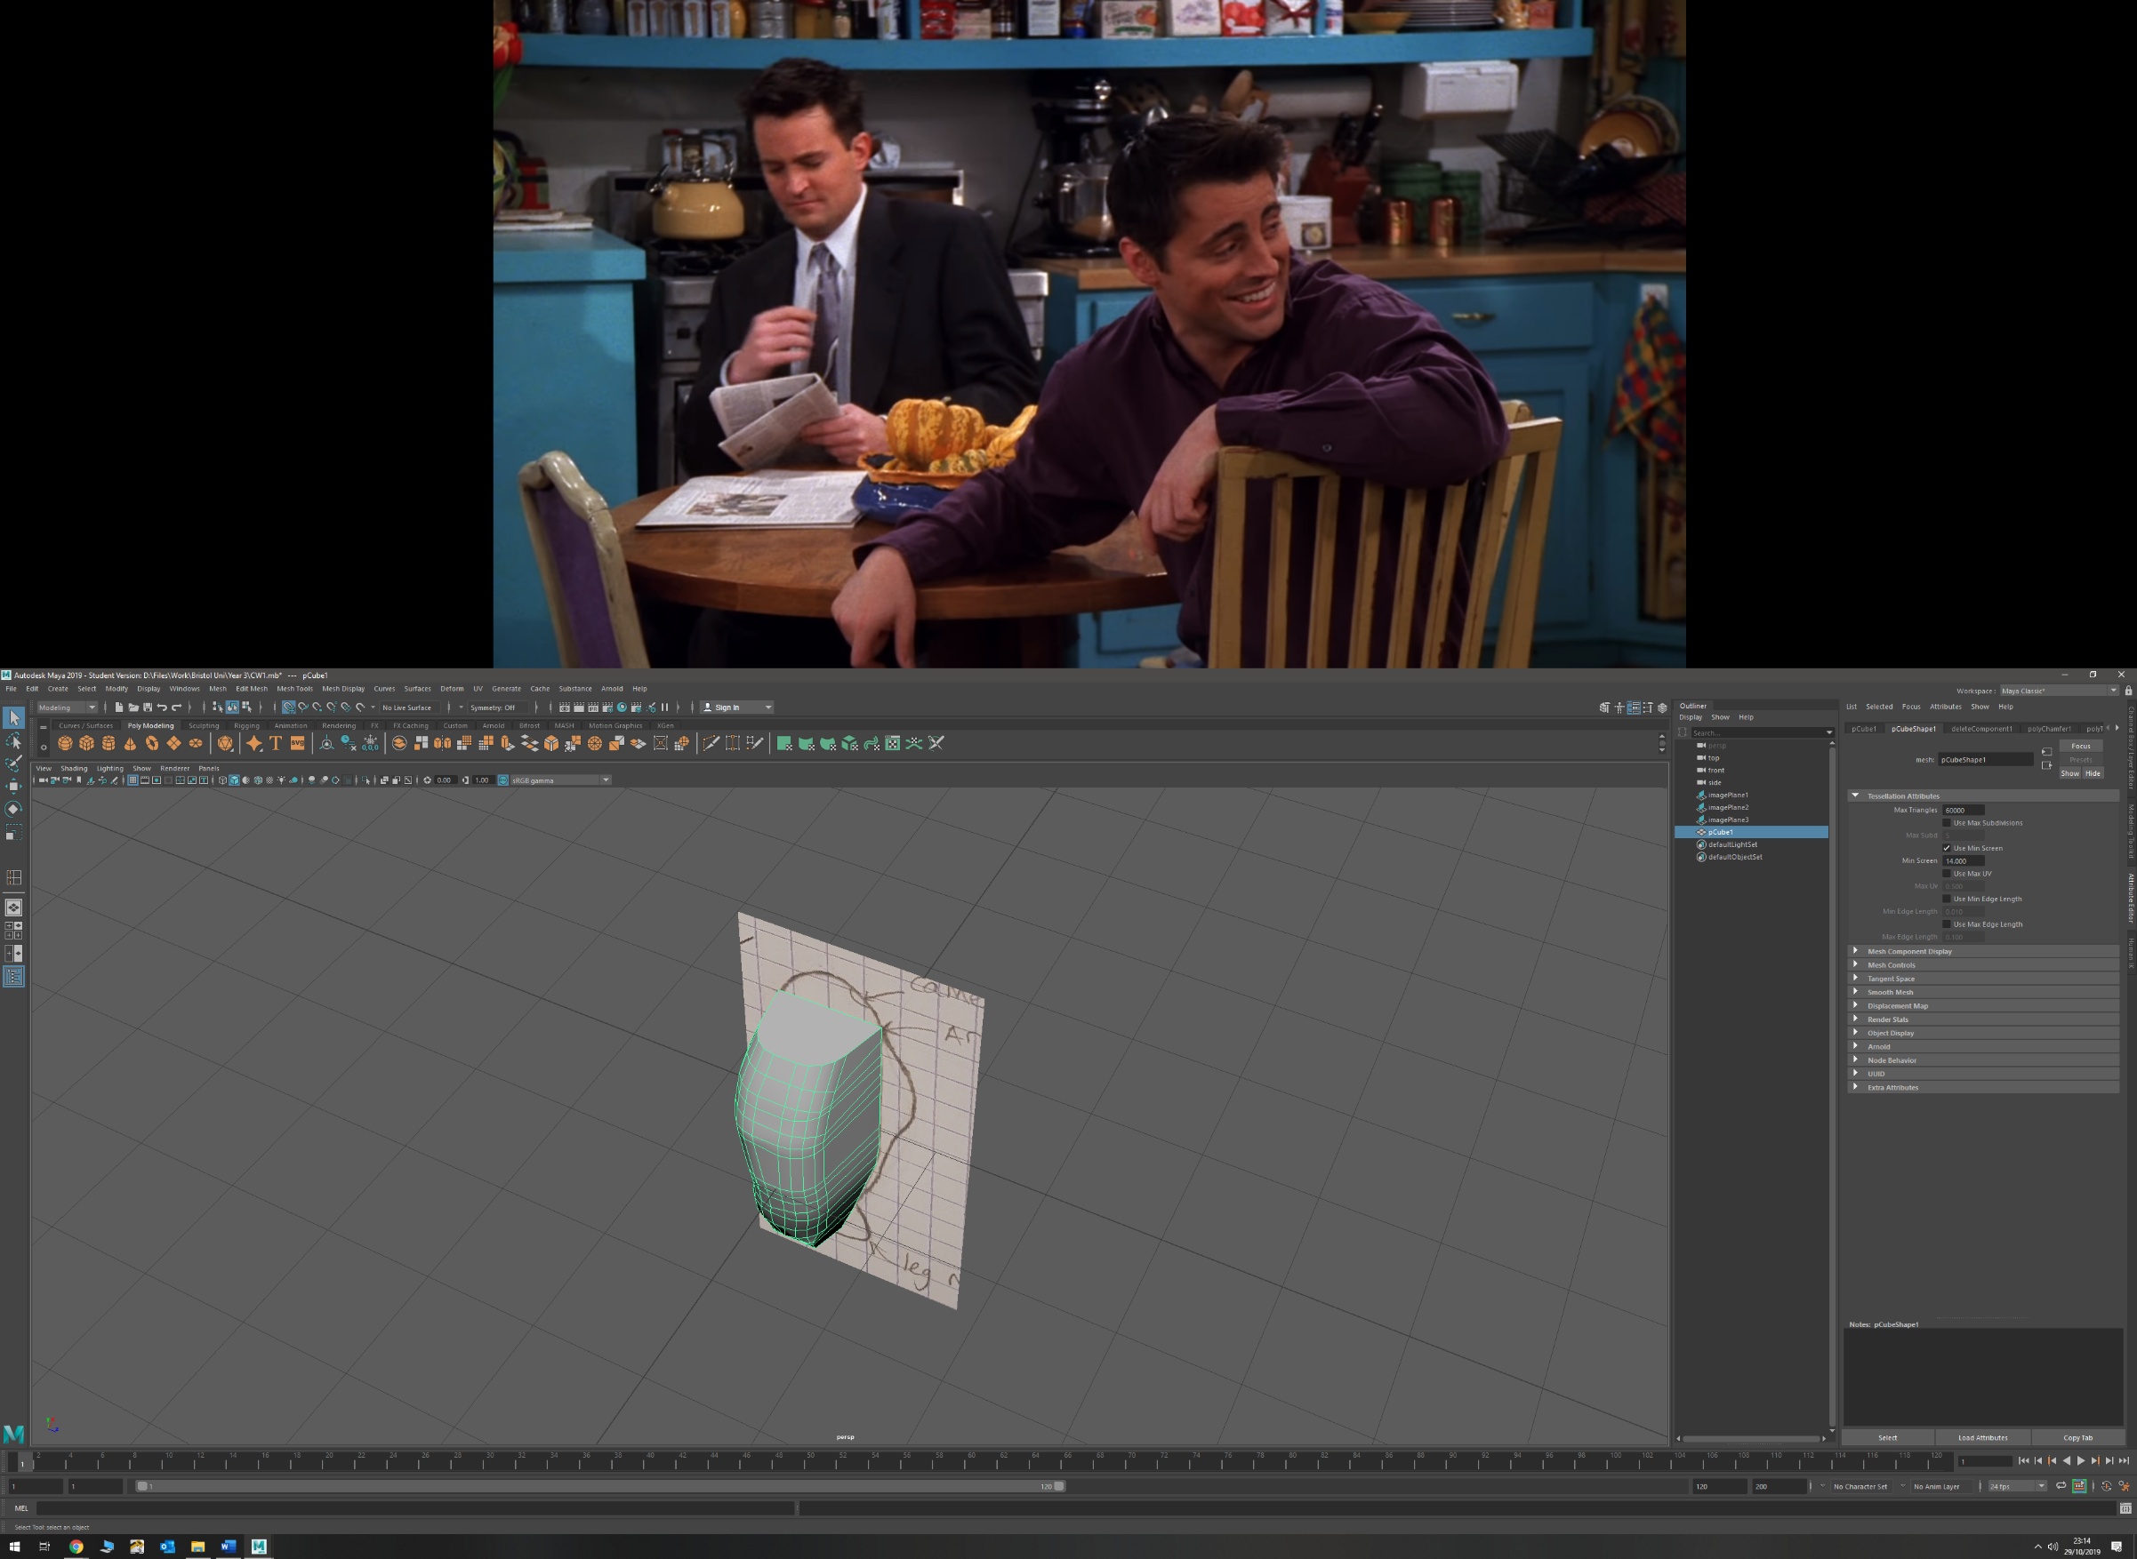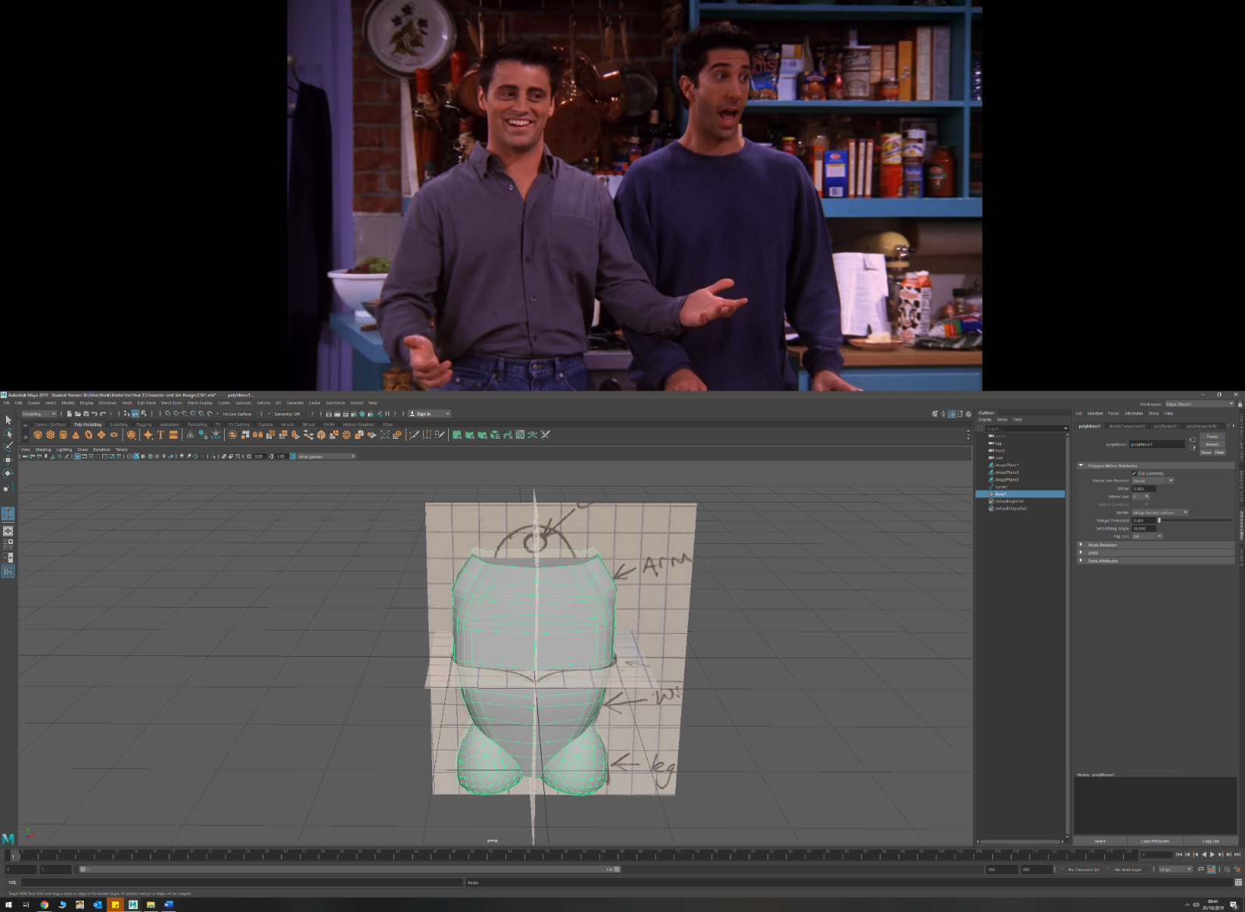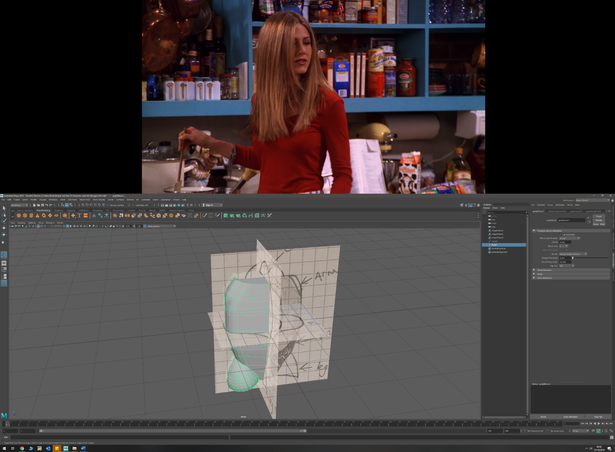

* Mirroring
  + Torso
* Duplication and inverting scale to flip
  + Arm
  + Leg
* Combining Polygons
  + Badminton racket mesh
  + Arm Exoskeleton mesh
* Tessellation (NURBS to polygon)
  + Leg mounts
  + Badminton Racket

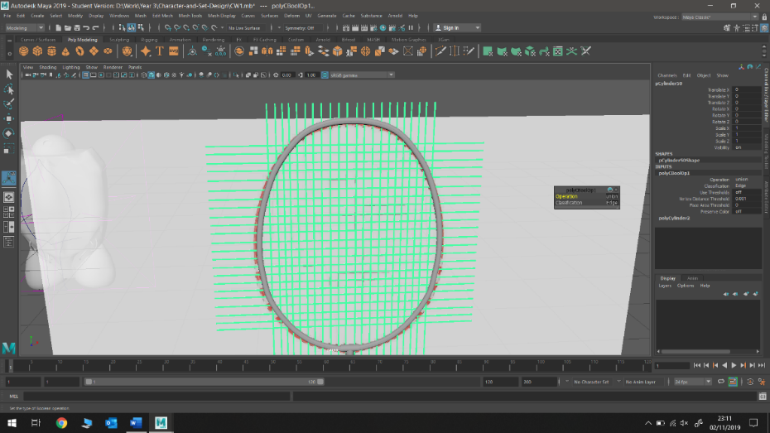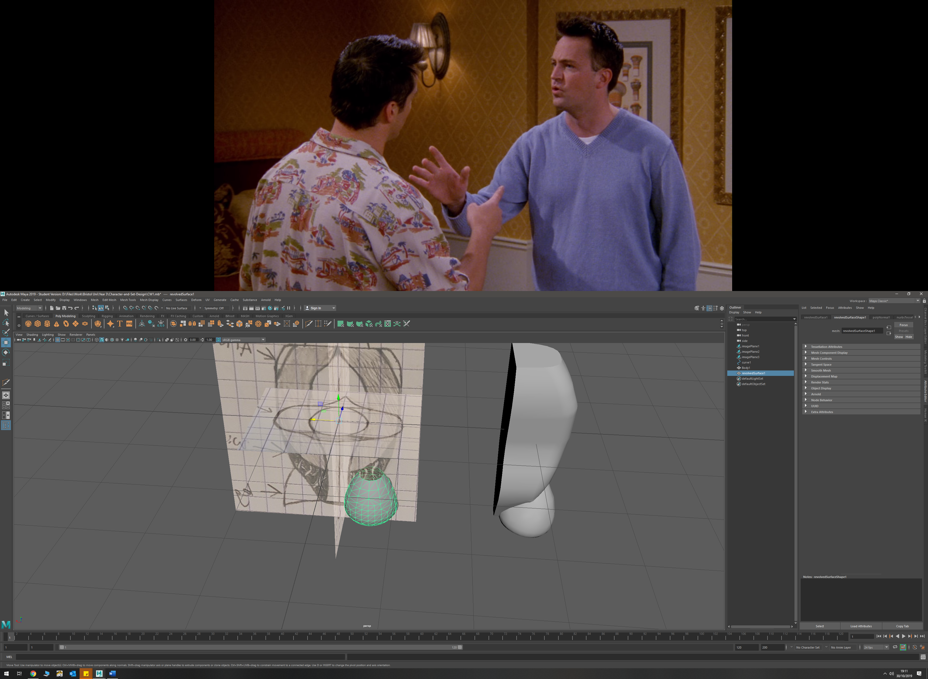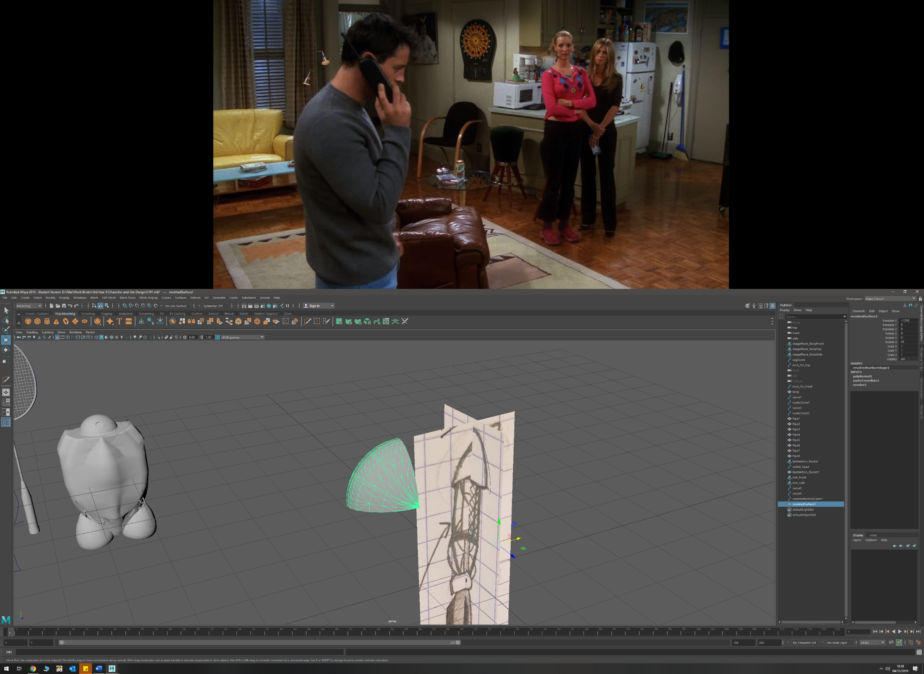

* Mass Duplication
  + Badminton racket mesh
  + Arm Exoskeleton side mesh
* Projection of curve onto surface
  + Aero-fin onto torso
* Revolving a profile curve
  + Leg mounts (360 degree)
  + Shoulder Pads (90 degree)

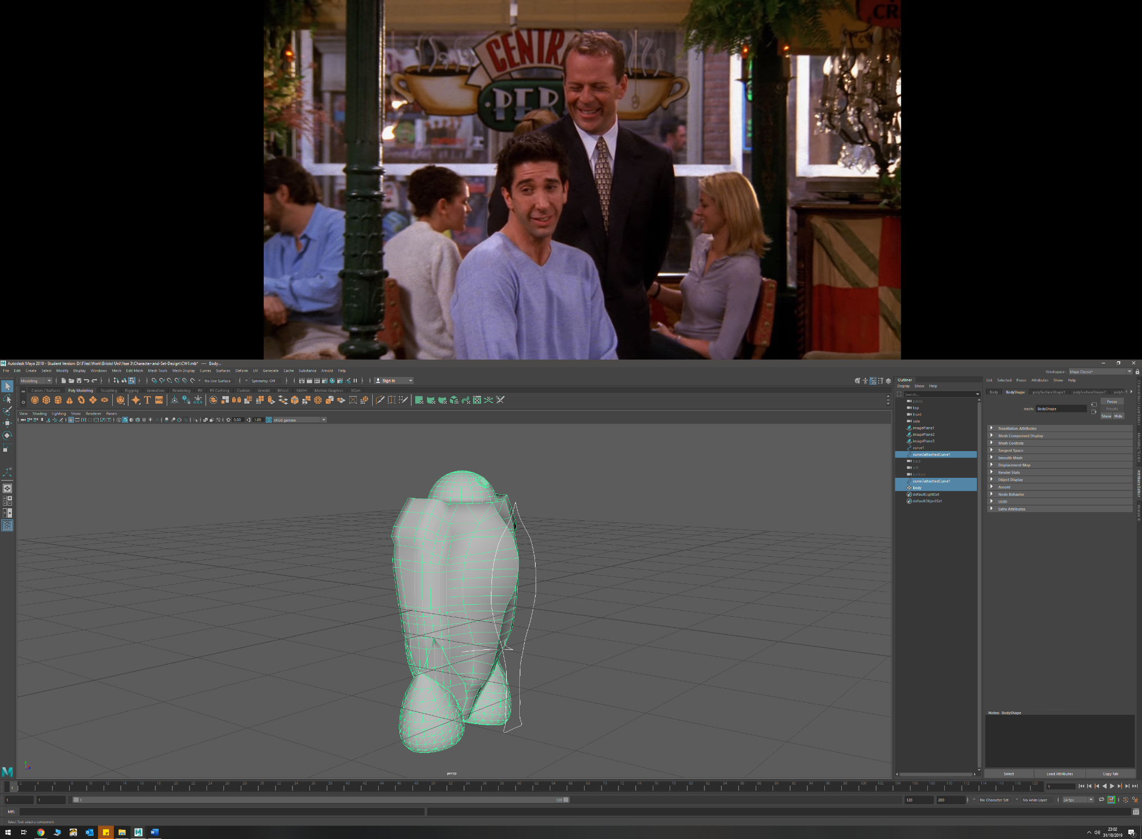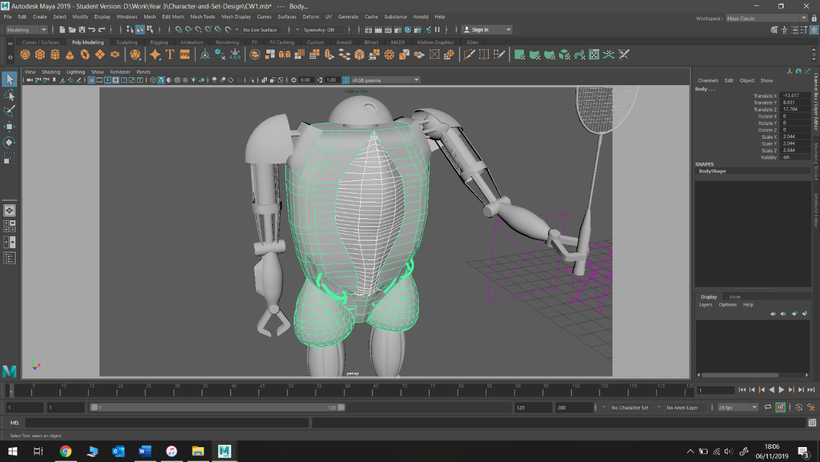

* Separating polygonal faces
  + Aero-fin from torso
  + Shoulder mounts from torso
  + Head from torso
* Smoothing by subdivision
  + Torso back in recessed detail to match curvature more smoothly
* Attaching two curves (create half of curve then duplicate and attach)
  + Badminton racket
  + Shoulder pad

**Process and Discussion**

Initially I started by modelling the robot’s body. I first imported the top, side, and front sketches into Maya so I could use the various orthographic views to model my designs off accurately. The body started as a cube, which I then scaled lengthways to be the total height of the body. At this point, I added in edge loops at numerous points along the height of the cube. This allowed me to then select the vertices and edges and drag them to match the desired curves I wanted for my robot’s torso. This process of moving the edges and vertices was repeated until the body of my robot had matched the dimensions of my blueprints both in size and geometrically.   
To create the taper at the bottom of the torso, I extruded the bottom edge downwards to the desired depth, and then scaled this bottom face to a smaller size in order to create the desired tapering inwards. Again, edge loops were added so that the torso could be formed to the correct dimensions of the blueprints.   
At this stage, I added a new cube, and scaled it up to be 4x4x4. I then positioned it, so its edge was over the origin (and middle of my torso object). Then using a binomial difference, I made a clean face where the middle of the torso would be. This enabled me to perform a mirror later in the modelling process once the torso was complete with leg mounts. This was so that I did not have to try and duplicate what I was doing on both sides of the model, providing a clean and consistent look to the model.

Primitive up modelling was chosen here for several reasons. Firstly, I wanted my robot to have a sharp geometric look to it, with subtle curves, to give it a rugged and as if it were constructed from metal panels. Using a curve and either revolving or extruding it did not make sense to me as this would have produced too smooth of an object. Additionally, having full control over the edges and vertices allowed me to alter the curvature of the back very easily, as well as quickly being able to create the desired taper towards the bottom. Furthermore, it was useful for later stages of modelling to have large, flat surfaces to extrude off, and to be able to easily modify the torso shape when desired.

To create the desired flow from the front round to the back of the torso, the frontmost side edge was bevelled using the bevel tool. In the tool settings, the number of bevels was increased to 4 in order to create a smoother transition. Using this tool proves very quick to use and gave me the desired effect with little effort or complexity, while also keeping the edge flow consistent and clean.  
The bevel tool was also used on the bottom edge of the torso to give the desired geometry. Again, the tool was chosen for its simplicity and ease of use.

The shoulder mount was created by extruding the faces towards the upper edge of the torso outwards, and then using the target weld tool on the surrounding edges to create clean curves easily. I did experiment by using the bevel tool to create the smooth edge, but this caused the shoulder mount to lose a lot of its size and did not create the desired sharpness. The weld tool however provided clean geometry, did the job quickly, and allowed for more control over the curvature of the corner. The top edge was left un-welded to add texture to the upper body of the robot. Additionally, it gave the shoulder mount a more pronounced look, which I preferred over what I had planned with my sketches.  
After doing an ambient occlusion of the model, the shoulder mounts were not as pronounced as I would have liked. To combat this, I separated the shoulder mounts faces from the main body object, making for a sharper interaction between the two objects. Doing this provided me with the crispness I wanted from the model.

Constructing the leg mounts was achieved my using the CV curve tool to trace over my sketch. A CV curve was selected so that I could create the rounded point on the lower part of the curve, which would create the desired lip once rotated. After rotating I ended up with an object that has a radius which was too big. To combat this, I changed the point about which the rotation was performed in the revolve tool’s settings. Whilst this gave me the desired shape after some trial and error, it did not provide clean edge flow, and had many overlapping edges and faces. I cleaned up this topology by deleting all the overlapping faces, and then using the fill hole tool. This was a quick and easy way of correcting the edge flow and removed a pole from the geometry. The leg mount was then positioned in the desired location, overlapping with the body somewhat, and converted from a NURBS to a polygon using tessellation. The body and leg mount where then joined using a Boolean union. This eliminated any non-manifold geometry that would have been caused by using a combine operation, whilst also allowing for easy modification to the leg mount’s position without disrupting the edge flow (before the history was deleted).

Towards the bottom third of the torso, I had planned to have visible piping and wires on the front, and a vent system on the back. To illustrate this detail in a more pronounced way, I used the multi-cut tool in order to alter the geometry of the torso in such a way to get the desired curve of the indentation. Once this was completed, I extruded the faces under said constructed edge curve inwards to create the desired depth.  
On the rear of the model, I decided I will add the venting detail when texturing and shading, as the desired detail could have created poles and poor edge flow due to the scale and small size of the desired meshing. However, if I had decided to make the mesh detail using polygons, I could have used a mesh of overlapping cylinders, and then use the bend tool in Maya to curve this mesh to the correct curvature of the torso section.

For the front section of the torso indentation, I decided to add some pipe details using geometry rather than in the texturing stage. This decision was made as the depth of overlapping pipes extruding from the torso would add realism and good detail to the model, whilst also not effecting the edge flow too badly.   
These pipes were constructed by drawing a curving EP curve, and then using the extrude tool with a scaled down NURBS circle prefab to create the pipe shape. To give a more chaotic but natural appearance to the pipe, I chose to twist the pipe by 270 degrees in the extrude tool settings. I then duplicated the resulting pipe, scaled some of these, and utilised the different sections to create a variety of overlapping pipes for both sides of the torso. Alternatively, I could have drawn more EP curves to create the pipe variation, but the method of duplication was much quicker, and still provided the end model with some degree of variety.  
To clean the overlapping topology of the pipes and the torso, a Boolean union was once again used to create a clean edge flow and prevent non-manifold topology.

The BB-8 inspired head was created by simply halving a sphere polygon prefab, and then shaping it to the correct size. This method proved quick and simple and gave me my desired look. Initially, the head was attached directly to the top of the torso via a union Boolean. However, this provided me with some weird rendering effects when the ambient occlusion was performed. This was combated by removing the bottom row of faces from the head sphere, filling the hole in the bottom, scaling this face inwards, then extruding this smaller face. Whilst this successfully combated the rendering issue, it additionally gave my model a more realistic appearance as it is clearer how the head can rotate separate to the torso.

To create the camera on the head, I used the circularise tool in Maya twice, to create an inner and outer band. I then extruded the face of the inner circle inwards, and the band outwards to create the lens in a simple way. This same effect could have been achieved by using a poke, or a Boolean with a cylinder, but the circularisation approach gave me more flexibility in camera dimensions, and ultimately a higher quality of detail with much less effort.

One of the main challenges of my model was constructing the aerodynamic bevel on the front of the torso. Initially I Traced round half of my blueprint design with an EP curve, then duplicated, flipped and attached these two curves to create a single symmetrical curve.   
From here I tried a few different techniques to get the desired look. First, I tried to do a 180 degree revolve, however this produced an object which was too rounded. So, to try and get the tapered bevel along the face of the fin which I desired, I traced my blueprint but from a top down view to create a bevelling of the correct shape. I duplicated this and lofted between them, then combined this with the original revolve using Boolean difference to try and achieve the desired look. However, this did not work, as the fin itself curves and tapers to a smaller size as it progresses down the torso, and so some of it is unaffected by the Boolean.   
To create the end product, I projected my complete, symmetrical curve shape onto the front of the torso, and used the *split mesh with projected curve* tool to imprint the curve onto the torso. From here I selected the vertices of the curve and manipulated them by hand to the desired look. In hindsight, this was not the most effective approach as it was time consuming, however it did give me the desired look whilst also giving me flexibility so slightly deviate from my original design.   
Adding in the Aerodynamic fin created some weird face topology towards the top of the torso, and so the smooth tool was used to even this out. However, this caused some artefacting to become present in the ambient occlusion. To combat this, I detached the aerodynamic fin from the body, and deleted all the faces from the upper front third of the torso. From here I filled used the fill hole tool to create a new face, and then used the multi-cut tool to add in edges to both improve edge flow and create a clean, even surface to the front of the torso once again. I could then keep the aerodynamic fin separate from the body and have a sharp distinct edge on the ambient occlusion render, akin to the shoulder mount.

The badminton racket was created using an imported image of one as reference. The head of the racket was made by extruding a NURBS circle along a CV curve with a very high polycount to give a spherical appearance to the tube. This method proves simple and quick, whilst allowing for precise realism.   
The racket mesh was created by mass duplicating a cylinder of correct proportions. Once duplicated the cylinders were combined, and a Boolean difference was performed between the mesh and a duplication of the racket head loop. This then enabled me to easily separate the outer mesh cylinders to the inner mesh and delete what wasn’t needed. Whilst this approach was crude, it was very quick and simple, and achieved a very realistic result.  
Primitive up modelling was used for the stem; from a single cylinder. Multiple extrudes of faces were used, along with scaling the faces outwards to increase the thickness when modelling the actual grip part of the handle. Whilst a revolve could have been used, the method used was very quick and allowed for a surprising amount of realism with very few extrude operations.

Similar to the leg mount, the shoulder pad was created using a revolve from an EP curve, except it was only revolved 90 degrees instead of 360. Again, doing the revolve produced some messy topology so the faces in the corners were removed. However, removing the faces gave an alternative look to the shoulder pad that fit the model well, and so they were left out. The whole shoulder pad was then extruded outwards to give it some thickness.

For the shoulder joint I simply used a prefab sphere. This is because very little of this component will be visible, so detail is not a concern.   
Altering from my sketches, the arm connects to the body via 4 spherical poles; like that of the T-800 from Terminator. These were created by using the circularise tool on four faces of the shoulder sphere and extruding them outwards. This design change adds some more detail to the model, while fitting in well with the original design.

The upper arm is composed on the most part from a hydraulic piston, which was simple created by scaling down the bottom face of a cylinder, and then extruding it downward to the required length. The detail for the arm is in the form of an exoskeleton frame and a wire circling the hydraulic piston.

The wire was created in a very similar way to the pipes. However, the curve points were transformed by hand, so the curve revolved around the hydraulic piston. After this manipulation was done, a NURBS circle was extruded along the EP curve, and then moved into place. Using an EP curve in this way provided great flexibility when moving the curve points around the piston, whilst also being a quick method of construction.

The upper arm exoskeleton was made by using an edited NURBS circle. The edge count was reduced to 8 to give it the shape of an octogen. This design choice was made to give off a more realistic impression that it was constructed from metal. The NURBS was then duplicated, and a loft was performed between the two, with an additional extrude to the whole object to give it thickness.  
The supporting beams coming from the octogen were created by simply extruding the faces upwards and downwards on both sides of it. The taper on the lower support beams was achieved by moving the extruded face inwards.  
The mesh on the side of the exoskeleton frame was created in an identical way to that of the badminton racket, as it is quick to perform and produces realistic looking results.

The forearm, clamps and thigh of the model are all constructed using primitive up modelling due to the speed at which the parts can be created, but also the flexibility they provide when needing to extrude off them. For the forearm, the fin detail was created by moving faces outwards to match the image plane sketch, with the bevel and weld tool being used afterwards to create the sloping angles back to the forearm. These tools provide a quick way of adding simple details to objects, while giving you the freedom to customise your design easily as you model.  
The thigh detail was achieved by simply moving the edges inwards slightly. Whilst simple, it produced the desired effect of a synthetic muscle, which can be further heightened in the texturing phase.  
Once more, the clamp utilises a few extrudes on faces and then a final bevel on the claw tip to create a realistic gripping edge.

The lower half of the leg was modelled off a Para-Olympian’s blade which is used in the current Olympics. The upper part of the prosthetic was made from a sphere cut in half, then extruding the exposed edges upwards to the correct height. The mounting plate for the blade was constructed using a cube primitive, which was scaled to the correct dimensions and combined with the upper prosthetic using a Boolean union to ensure non-manifold topology.

The running blade itself was traced over from my sketch using EP curve. This curve was duplicated, and a loft was used to create the correct surface. The polycount did have to be increased to more realistically create the flow of a prosthetic blade, and an extrude was used to make the blade a little thicker.  
Detail was added to the rear of the blade in the form of mounting screws. Theses are simply constructed from circularising faces on the upper blade and extruding them slightly. This detail adds to the prosthetics realism, giving the robot an overall more genuine feel.

The most difficult part of modelling was adding in my shaped, bevelled aerodynamic fin due to the complexity of its geometry. Unsurprisingly, this is also one part of the model I am most proud of, as I achieved the look I desired. Another difficult section was creating a well flowing edge topology for the object. This took me a big chunk of time to work out the most effective way of altering and fixing broken or messy topology and did get very confusing at times, especially when faces started to overlap.  
Another section I am especially proud of is the small details such as the pipes on the front of the torso, or the wire and mesh on the upper arm. I feel that these small details create a more realistic looking model by breaking up the blank faces of the model, whilst being simple to create and implement.

If done again, I would take more time to fix edge flow topology as I go along instead of leaving most of it to the end. Doing this proved much more difficult as there was more geometry that could interfere with pre-existing items, and therefore took more time to fix. One main culprit of this is overuse of Boolean union to combine objects together, as whilst this ensures manifold topology, it can majorly disrupt edge flow, and create some weird rendering artefacting.

**Appendix**

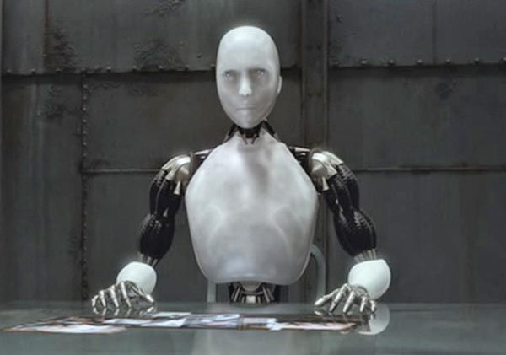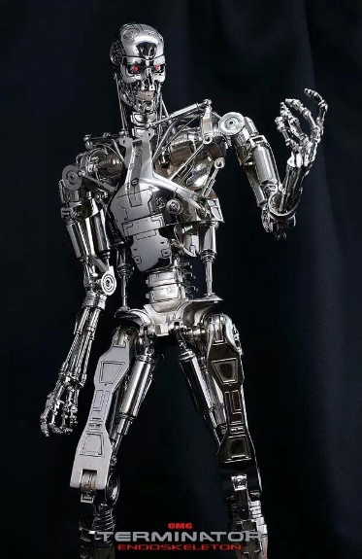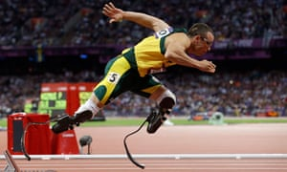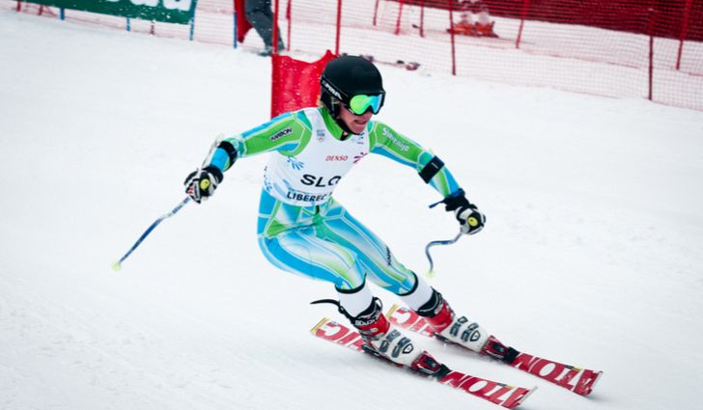**Style Sheet and Visual References**

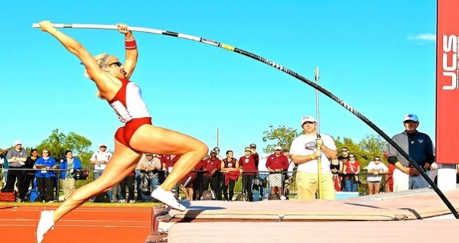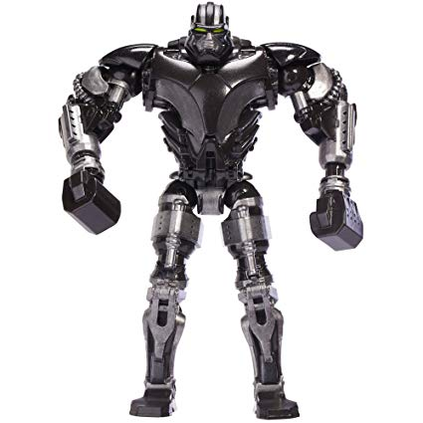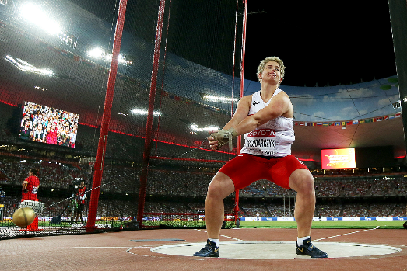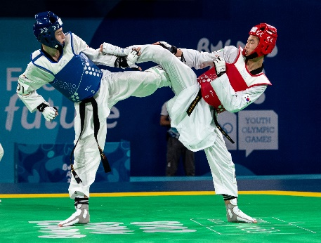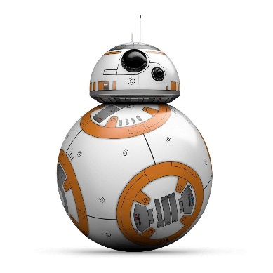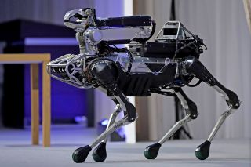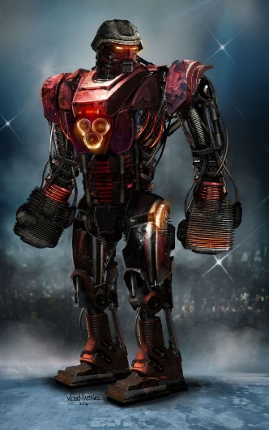

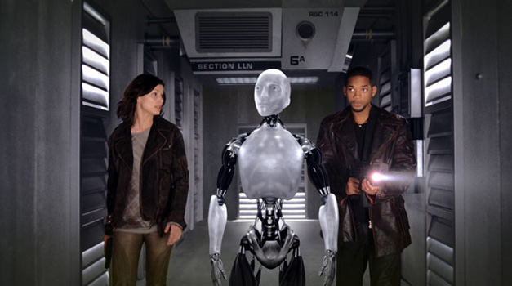

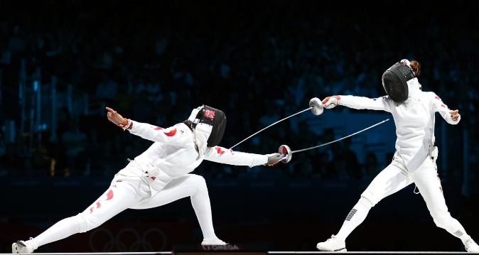

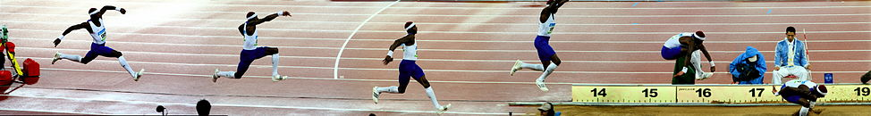

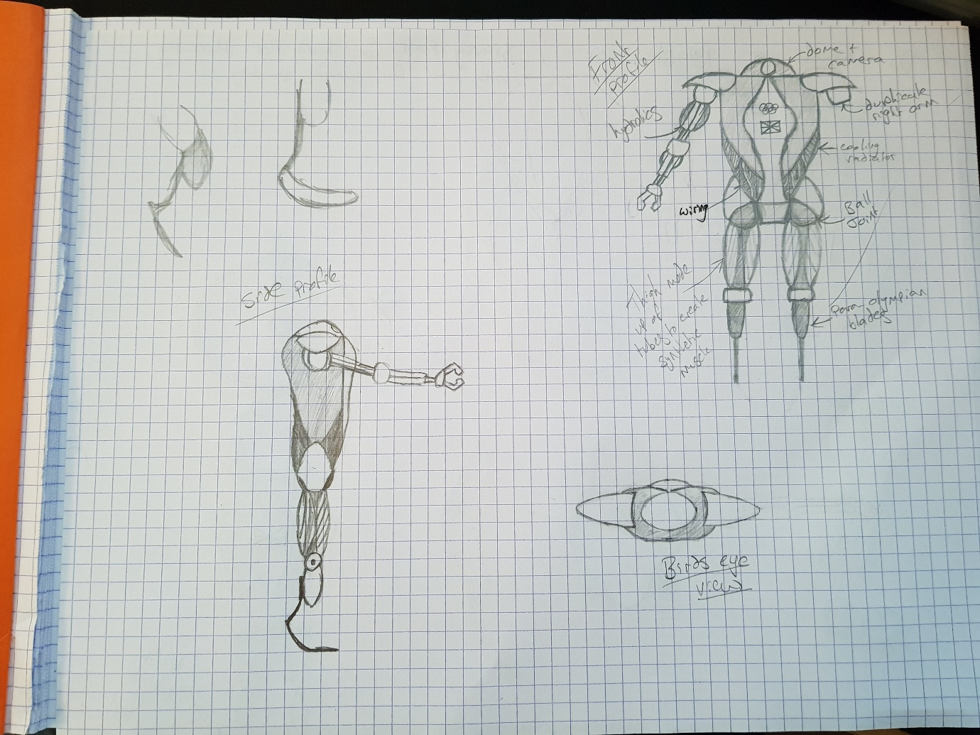**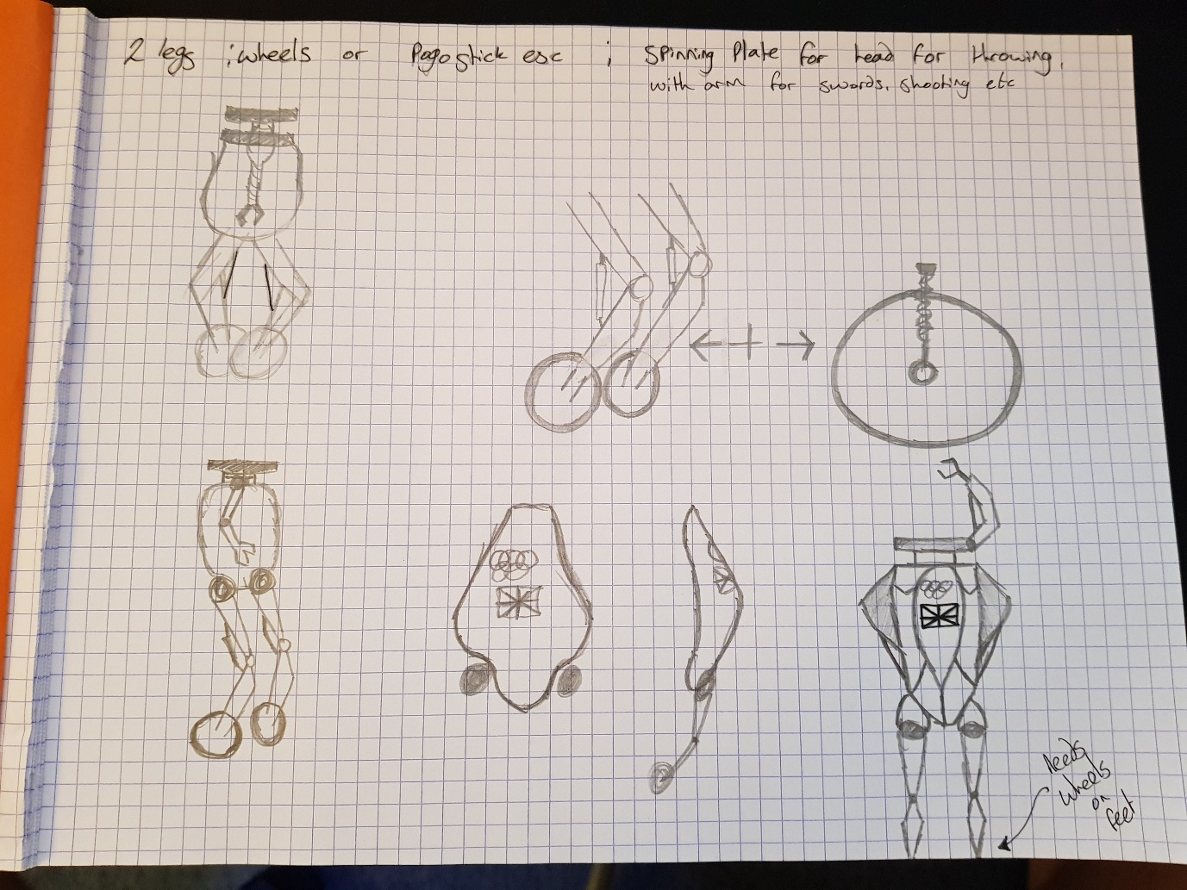Development Drawings**

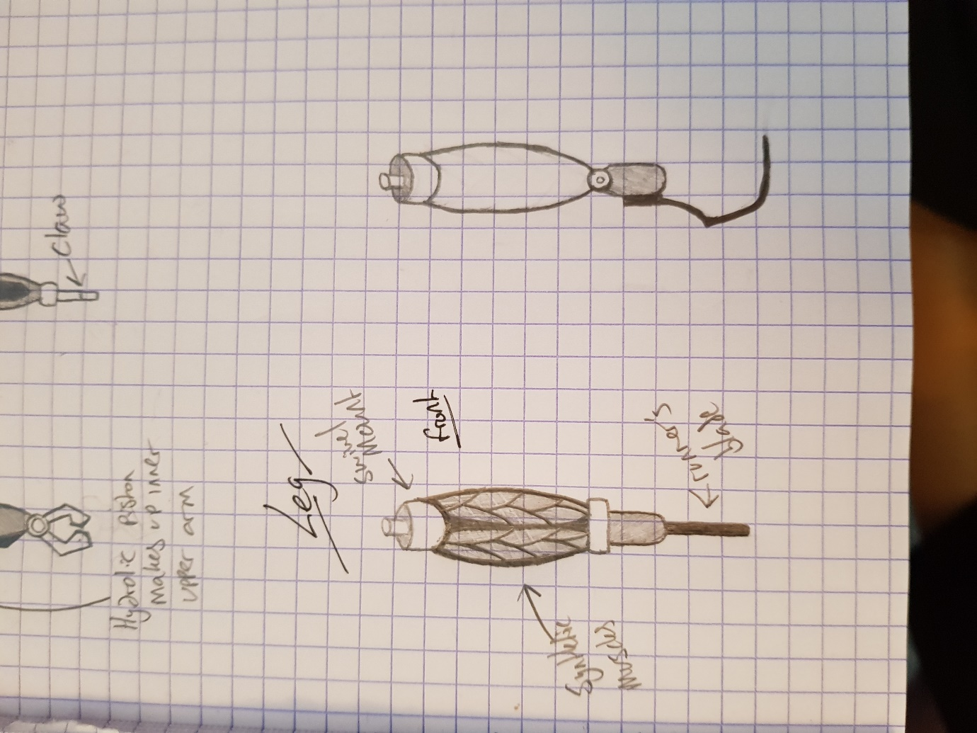**Sketches and Blueprints**

